Quality of Service (QoS) Monitoring of Cellular Mobile Data Services-Upper West Region
[May 2016]
[Communications for Development]

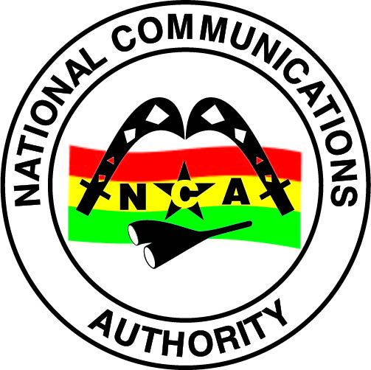
NATIONAL COMMUNICATIONS AUTHORITY

Table of Contents
1. Background 2
2. What we measure 2
3. Findings 2-5
4. Remedies 5
5. Appendix 5 - 12

Background
In pursuance of obligations of the 3G Cellular Mobile Licence of Telecommunication Operators, the consumer perspective of the quality of data services are tested to ensure the compliance of Operators to the obligations on service quality to the user.
The report is based on findings on quality of data service in the Upper West Region between 6th May and 10th May, 2016 for all Operators except Expresso due to technical challenges.

What we measure

As per the 3G Cellular Mobile licence obligations, the QoS indicators and their respective threshold for compliance under assessment considering the user’s perspective are as below;

- Data Access Success Rate (DASR)
- Data Drop Rate (DDR)
- Data Throughput

Findings

The results for the District Capitals within Upper West Region tested during the period are as below:

- Data Access Success Rate

Data Access Success Rate is the probability of success in connecting to the public server.
Data Access Success Rate should be equal or better than ninety-five per cent (95%)
For analysis and calculations,
$\text{Packet Service Failure Rate }\left[\text{\%}\right]=\frac{\text{Number of successful PDP Context Activations}}{\text{Total number of PDP Context Activation requests}}×\text{100\%}$
The results for the district capitals tested during the period are as below:

Table 1. Data Access Success Rate, May 2016
DISTRICT CAPITAL | MTN | VODAFONE | TIGO | AIRTEL | GLO
Funsi | 100 | 100 | No 3G Coverage | 100 | No 3G Coverage
Gwollu | 100 | 100 | 100 | 97.50 | No 3G Coverage
Jirapa | 100 | 100 | 91.30 | No 3G Coverage | No 3G Coverage
Lambussie | 100 | 100 | No 3G Coverage | 100 | No 3G Coverage
Lawra | 100 | 100 | 96.77 | 100 | No 3G Coverage
Tumu | 100 | 100 | No 3G Coverage | 100 | No 3G Coverage
Wa | 100 | 100 | 96.55 | 93.53 | 99.41
Wechiau | 100 | 100 | 100 | 100 | No 3G Coverage

REMARKS:
- MTN, Vodafone and Glo complied with the Data Access Success Rate obligation in all the available District Capitals tested.
- Airtel failed the Data Access Success Rate obligation at Wa.
- Tigo failed the Data Access Success Rate obligation at Jirapa.

- Data Drop Rate

Data Drop Rate is the probability to drop in connection to a public server without end user’s intervention.
Data Drop Rate should be equal or less than one per cent (1%).
$$\text{Data Drop Rate }\left[\text{\%}\right]=\frac{\text{Number of aborted PDP context activations}}{\text{Total number of PDP Context Activation requests}}×\text{100\%}$$
Table 2. Data Drop Rate, May 2016
DISTRICT CAPITAL | MTN | VODAFONE | TIGO | AIRTEL | GLO
Funsi | 0 | 0 | No 3G Coverage | 0 | No 3G Coverage
Gwollu | 0 | 0 | 0 | 0 | No 3G Coverage
Jirapa | 0 | 0 | 0 | No 3G Coverage | No 3G Coverage
Lambussie | 0 | 0 | No 3G Coverage | 0 | No 3G Coverage
Lawra | 0 | 0 | 0 | 0 | No 3G Coverage
DISTRICT CAPITAL | MTN | VODAFONE | TIGO | AIRTEL | GLO
Tumu | 0 | 0 | No 3G Coverage | 0 | No 3G Coverage
Wa | 0 | 0 | 0 | 0 | 0
Wechiau | 0 | 0 | 0 | 0 | No 3G Coverage

REMARKS:
- All Operators complied with the licence threshold of less than one percent (1%) in the available District Capitals tested.

- Data Throughput

Data Throughput is the rate of Data transfer.
As per the 3G licence obligations, the minimum data transfer rate for 90% of data connections should be 256kbps or better

Table 3. Data Throughput, May 2016
DISTRICT CAPITAL | MTN | VODAFONE | TIGO | AIRTEL | GLO
Funsi | 9190.59 | 1624.19 | No 3G Coverage | 2548.10 | No 3G Coverage
Gwollu | 8830.63 | 3971.14 | 2563.00 | 1867.25 | No 3G Coverage
Jirapa | 5859.58 | 2114.92 | 2908.35 | No 3G Coverage | No 3G Coverage
Lambussie | 9573.17 | 3309.01 | No 3G Coverage | 1690.59 | No 3G Coverage
Lawra | 7360.18 | 3099.59 | 2810.99 | 6729.42 | No 3G Coverage
Tumu | 8166.37 | 3883.32 | No 3G Coverage | 682.53 | No 3G Coverage
Wa | 3770.65 | 2214.17 | 1587.65 | 5026.98 | 1916.75
Wechiau | 9170.50 | 3705.01 | 3081.37 | 3777.14 | No 3G Coverage

REMARKS:
- All Operators complied with the licence threshold of 256kbps or more in the available District Capitals tested.

REMEDIES
- The NCA has notified Operators of publication of these findings and directed all Operators to improve any obligation in default by September, 2016.
- Sanctions will be applied to Operators on obligations in default after September, 2016.

- Glo was directed to improve their 3G Service in the Upper West Region by December, 2016.

APPENDIX 1
The Graphs below show the Throughput levels attained by Operators in each location where monitoring was performed.

Figure 1. Data Throughput May 2016, Funsi
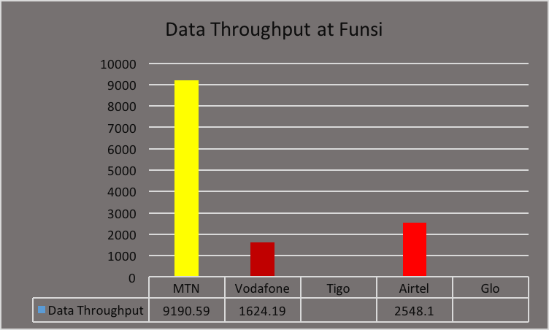
REMARKS:
- MTN, Vodafone and Airtel exceeded Data Throughput threshold of 256kbps.
- Tigo and Glo had no 3G Service at the time of the test.

Figure 2. Data Throughput May 2016, Gwollu
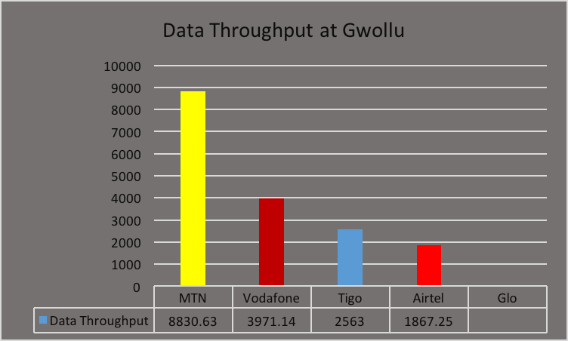
REMARKS:
- MTN, Vodafone, Tigo and Airtel exceeded Data Throughput threshold of 256kbps.
- Glo had no 3G Service at the time of the tests.

Figure 3. Data Throughput May 2016, Jirapa
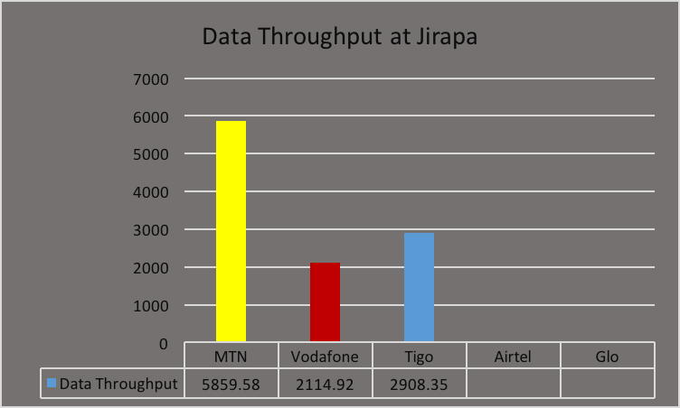
REMARKS:
- MTN, Vodafone and Tigo exceeded Data Throughput threshold of 256kbps.
- Airtel and Glo had no 3G Service at the time of the test.

Figure 4. Data Throughput May 2016, Lambussie
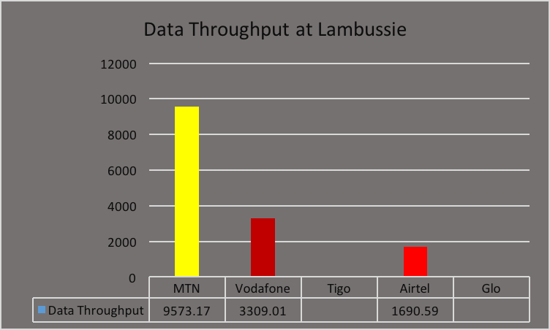
REMARKS:
- MTN, Vodafone and Airtel exceeded the Data Throughput threshold of 256kbps.
- Tigo and Glo had no 3G Service at the time of the test.

Figure 5. Data Throughput May 2016, Lawra
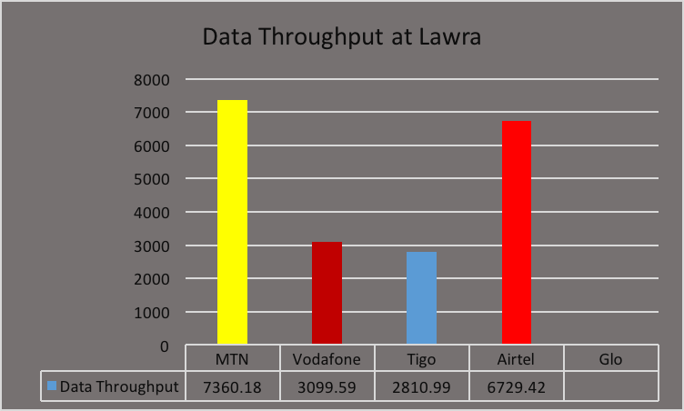
REMARKS:
- All Operators except Glo exceeded the Data Throughput threshold of 256kbps.
- Glo had no 3G service at the time of the test.

Figure 6. Data Throughput May 2016, Tumu
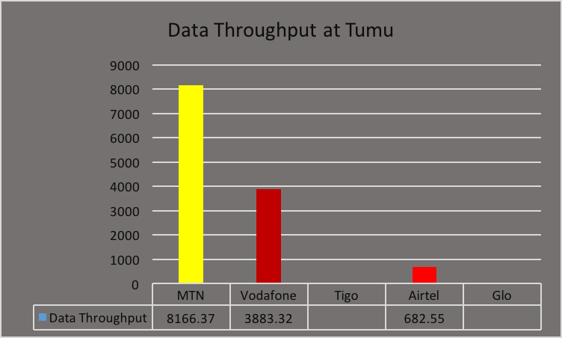
REMARKS:
- MTN, Vodafone and Airtel exceeded Data Throughput threshold of 256kbps.
- Tigo and Glo had no 3G Service at the time of the test.

Figure 7. Data Throughput May 2016, Wa Commercial Area
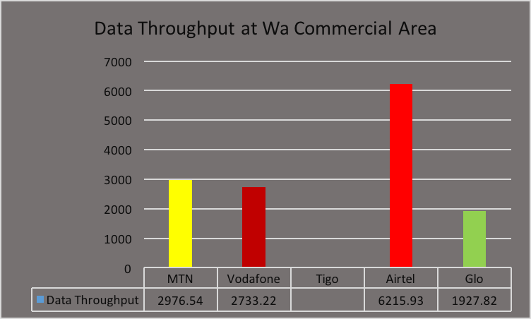
REMARKS:
- MTN, Vodafone, Airtel and Glo exceeded Data Throughput threshold of 256kbps.
- Tigo had no 3G Service at the time of the test.

Figure 8. Data Throughput May 2016, Wa-Dondole
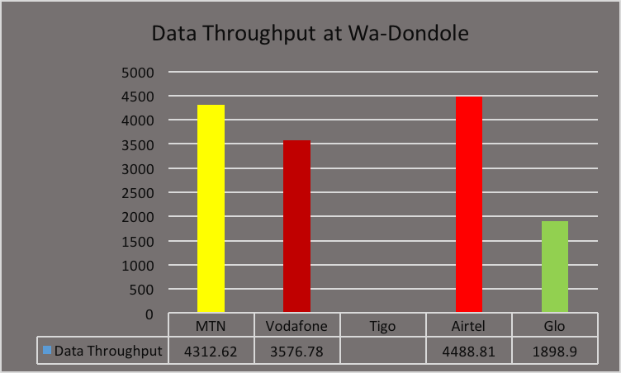
REMARKS:
- MTN, Vodafone, Airtel and Glo exceeded the Data Throughput threshold of 256kbps.
- Tigo had no 3G Service at the time of the test.

Figure 9. Data Throughput May 2016, Wa In-Service
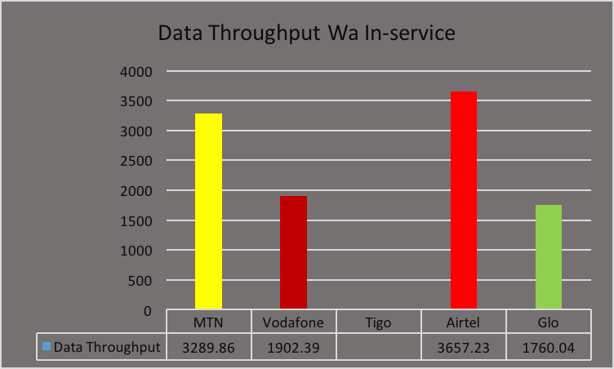
REMARKS:
- MTN, Vodafone, Airtel and Glo exceeded the Data Throughput threshold of 256kbps.
- Tigo had no 3G Service at the time of the test.
Figure 10. Data Throughput May 2016, Wa-Jubilee
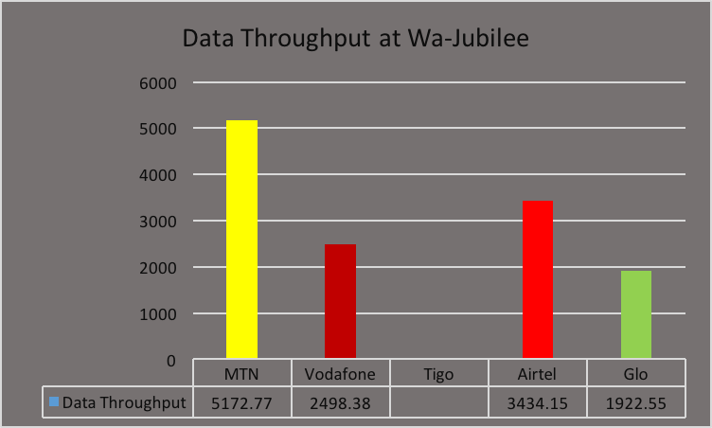
REMARKS:
- MTN, Vodafone, Airtel and Glo exceeded the Data Throughput threshold of 256kbps.
- Tigo had no 3G Service at the time of the test.

Figure 11. Data Throughput May 2016, Wa-SSNIT
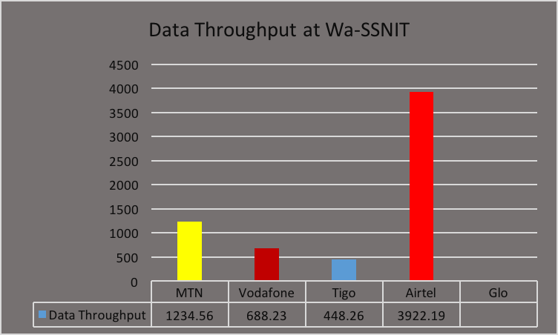
REMARKS:
- MTN, Vodafone, Airtel and Tigo exceeded the Data Throughput threshold of 256kbps.
- Glo had no 3G Service at the time of the test.
Figure 12. Data Throughput May 2016, Wa-Teagber
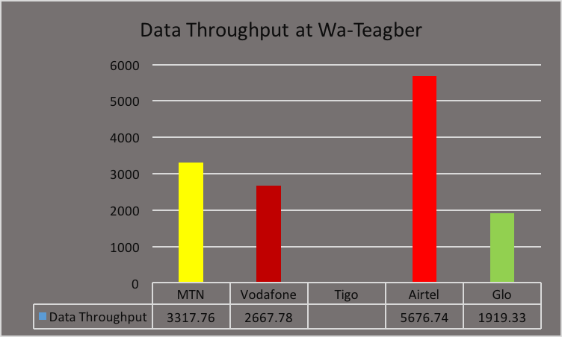
REMARKS:
- MTN, Vodafone, Airtel and Glo exceeded the Data Throughput threshold of 256kbps.
- Tigo had no 3G Service at the time of the test.
Figure 13. Data Throughput May 2016, University of Development Studies
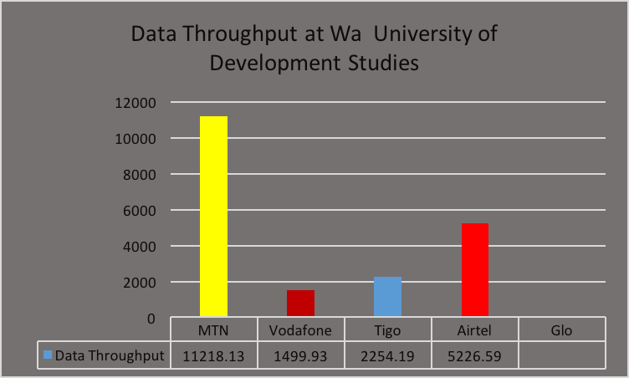
REMARKS:
- MTN, Vodafone, Tigo and Airtel exceeded the Data Throughput threshold of 256kbps.
- Glo had no 3G Service at the time of the test.

Figure 14. Data Throughput May 2016, Wa Polytechnic
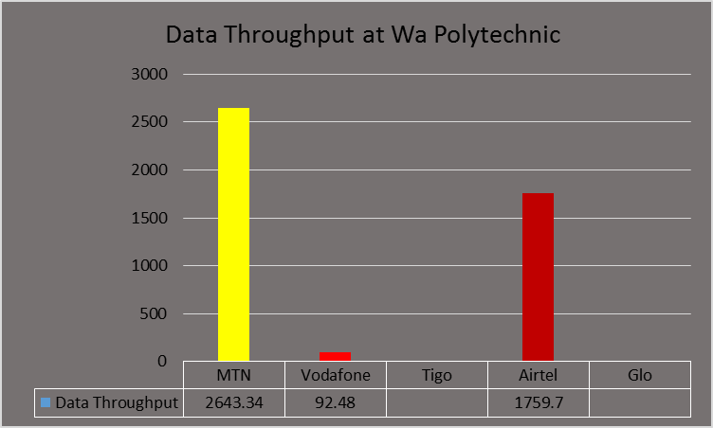
EMARKS:
- MTN and Airtel exceeded the Data Throughput threshold of 256kbps.
- Vodafone failed the Data Throughput licence condition at Wa Polytechnic.
- Tigo and Glo had no 3G Service at the time of the test.

Figure 15. Data Throughput May 2016, Wa Technical Institute
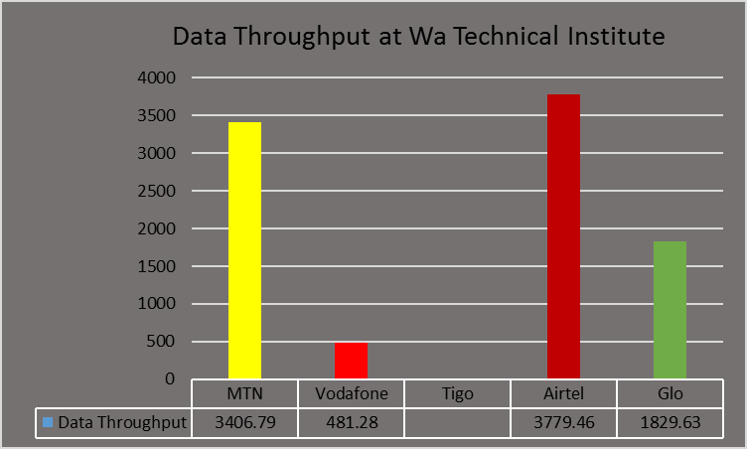
REMARKS:
- MTN, Vodafone, Airtel and Glo exceeded the Data Throughput threshold of 256kbps.
- Tigo had no 3G Service at the time of the test.
Figure 16. Data Throughput May 2016, Wechiau
REMARKS:
- MTN, Vodafone, Tigo and Airtel exceeded the Data Throughput threshold of 256kbps.
- Glo had no 3G Service at the time of the test.

