3G Coverage Assessment of Cellular Mobile Services- Greater Accra Region
[January – February 2016]
[Communications for Development]

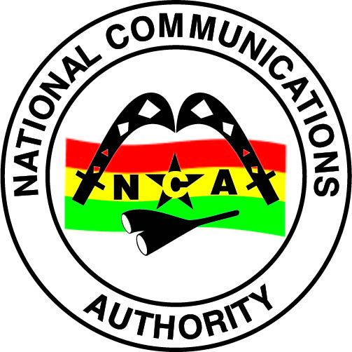
NATIONAL COMMUNICATIONS AUTHORITY

Table of Contents
1. Background 2
2. What we measure 2
3. Findings 2-3
4. Remedies 4
5. Coverage Signal Strength 5-42

Background
In pursuance of obligations of the 3G Cellular Mobile Licence of Telecommunication Operators, the consumer perspective of the 3G Coverage status are tested to ensure the compliance of Operators to the obligations on 3G Coverage to the user.
The report is based on findings on 3G verification campaign in the Greater Accra Region from 26th January to 29th February 2016 for all Operators except for Expresso due to technical challenges.

What we measure
As per the 3G Cellular Mobile licence obligations, 3G-locked mode coverage samples are collected to obtain on the average a signal strength measurement which is representative of the coverage situation in each of the District Capital that was driven.
The 3G Signal Strength and their respective threshold for compliance considering the user’s perspective are categorised as follows;
Rating | 3G Signal Strength Range (dBm)
No 3G Coverage | -105>RSCP
Poor | –105≤ RSCP < -95
Fair | –95≤ RSCP< –85
Good | –85 ≤RSCP < –20

Findings
The results for the district capitals within Greater Accra Region tested during the period are as below:
Table 1: Coverage Signal strength, January – February, 2016
DISTRICT CAPITAL | MTN | VODAFONE | TIGO | AIRTEL | GLO
ABOKOBI | Good | Good | Good | Good | Poor
ACCRA | Good | Good | Good | Good | Good
ADA FOAH | Good | Good | No 3G Coverage | Fair | No 3G Coverage
DISTRICT CAPITAL | MTN | VODAFONE | TIGO | AIRTEL | GLO
ADENTA | Good | Good | Good | Good | Poor
ASHAIMAN | Good | Good | Good | Good | Good
DODOWA | Good | Good | Good | Fair | No 3G Coverage
GBAWE | Good | Good | Good | Good | Good
KPONE | Good | Good | Good | Good | Good
LA | Good | Good | Good | Good | Good
MADINA | Good | Good | Good | Fair | Good
PRAMPRAM | Good | Good | Good | Fair | No 3G Coverage
SEGE | Good | No 3G Coverage | No 3G Coverage | No 3G Coverage | No 3G Coverage
SOWUTUOM | Good | Good | Good | Good | Good
TEMA | Good | Good | Good | Good | Poor
TESHIE NUNGUA | Good | Good | Good | Good | Poor
REMARKS:
- MTN had good 3G Coverage in all 15 district capitals tested.
- Vodafone had good 3G coverage in all district capitals tested except Sege where the coverage was non-existent in the most parts of the capital.
- Tigo had good 3G coverage in all district capitals tested except Sege and Ada Foah where the coverage was non-existent.
- Airtel had good 3G coverage in Abokobi, Accra, Adenta, Ashaiman, Gbawe, Kpone, La, Sowutuom, Tema and Teshie Nungua.
- Airtel had fair 3G coverage in Ada Foah, Madina, Dodowa and Prampram.
- Airtel had no 3G coverage in Sege.
- Glo had good 3G coverage in Accra, Ada Foah, Gbawe, Kpone, La, Madina and Sowutuom.
- Glo had poor 3G coverage in Abokobi, Adenta, Tema and Teshie Nungua.
- Glo had no 3G Coverage in Ada Foah, Dodowa, Prampram and Sege.
Remedies
- Tigo has been sanctioned for failing to maintain coverage at Ada Foah.
- All Operators were given a deadline of 31st December 2016 to provide 3G coverage in Sege.
- All Operators were directed to improve their existing 3G coverage by 31st July 2016.

APPENDICES

Coverage Signal Strength

The Maps below show the coverage level in District Capitals of the Northern Region where monitoring was performed. The coverage map is based on the 3G network signal strength when tested in an idle mode. In each plot is a legend to indicate the signal strength and quality range attained by Operators during measurement.

Coverage levels in green falls in the range of -85dBm and above, and are considered good. Those between -85 and -95dBm are considered average or fair and are indicated in yellow. The red samples represent worse or poor coverage in the range of -95 to -105dBm. The black samples represent areas with no 3G coverage.

Coverage Legend
Colour | Area Coverage Rating
 | Good Coverage Areas
 | Fair Coverage Areas
 | Poor Coverage Areas
 | Non-Existent Coverage Areas

APPENDIX I

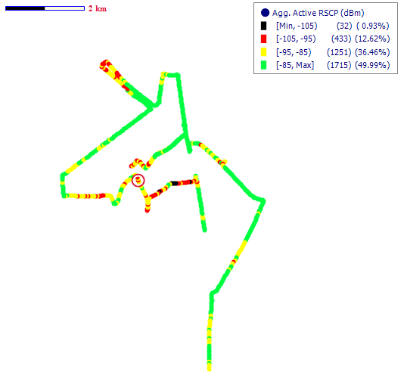
COVERAGE AT ABOKOBI
Fig. 1 – MTN 3G Coverage Map, Abokobi - February 2016
Remarks: Good 3G coverage at Abokobi

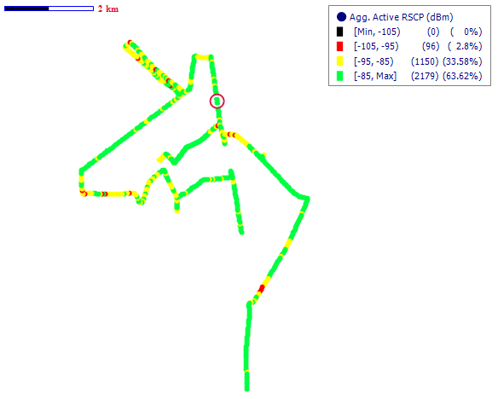
Fig. 2 – Vodafone 3G Coverage Map, Abokobi - February 2016
Remarks: Good 3G coverage at Abokobi
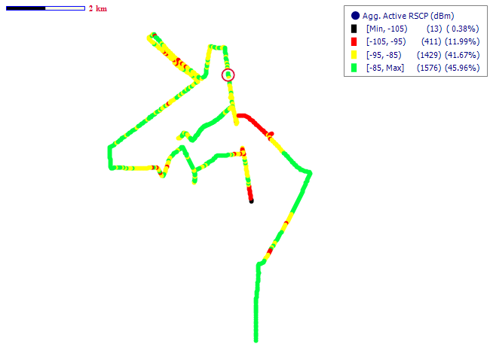
Fig. 3 – Tigo 3G Coverage Map, Abokobi - February 2016
Remarks: Good 3G coverage at Abokobi

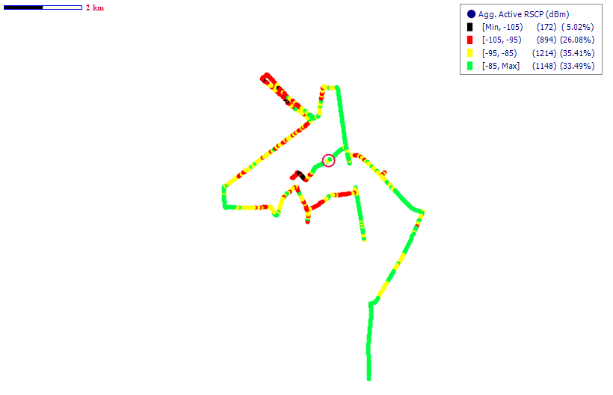
Fig. 4 – Airtel 3G Coverage Map, Abokobi - February 2016
Remarks: Good 3G coverage at Abokobi however improvement is needed.
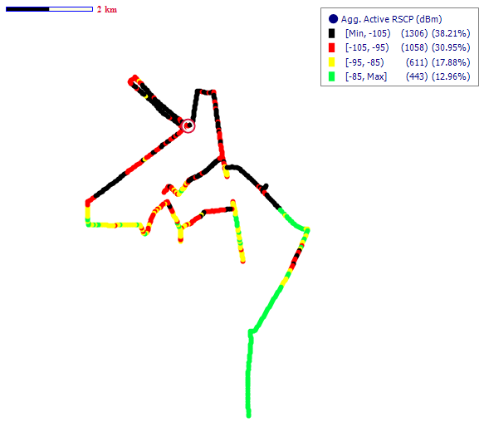
Fig. 5 – Glo 3G Coverage Map, Abokobi - February 2016
Remarks: Poor 3G coverage at Abokobi that needs to be improved

COVERAGE AT ACCRA
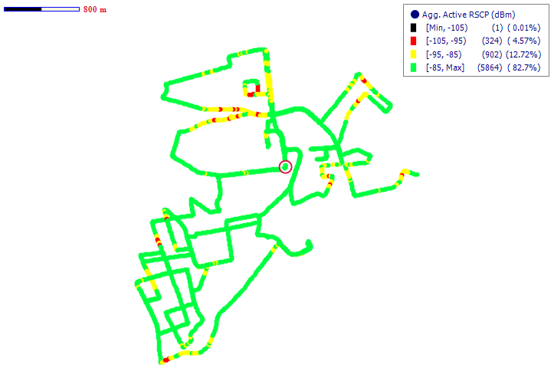
Fig. 6 - MTN 3G Coverage Map, Accra - February 2016
Remarks: Good 3G coverage in Accra.

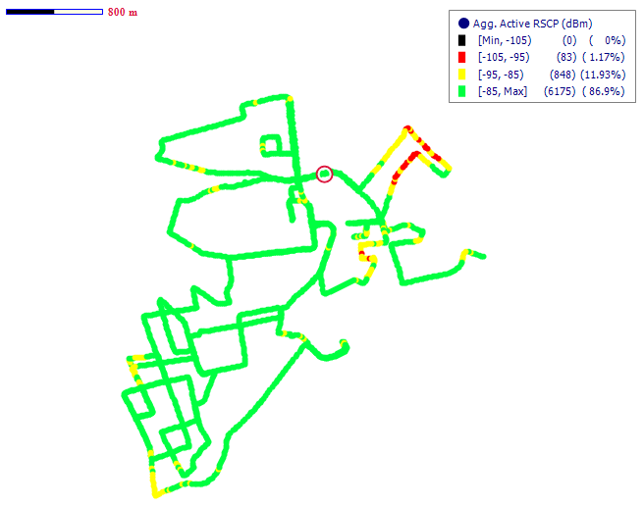
Fig. 7 - Vodafone 3G Coverage Map, Accra - February 2016
Remarks: Good 3G coverage in Accra

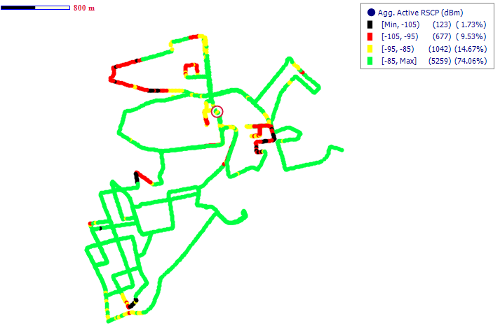
Fig. 8 - Tigo 3G Coverage Map, Accra- February 2016
Remarks: Fair 3G network coverage in Accra however improvement is needed.
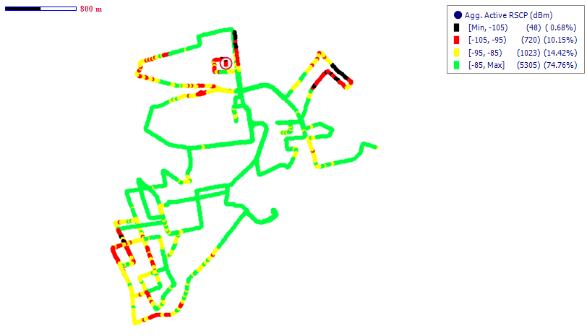
Fig. 9 - Airtel 3G Coverage Map, Accra - February 2016
Remarks: Fair 3G coverage in Accra however improvement is needed

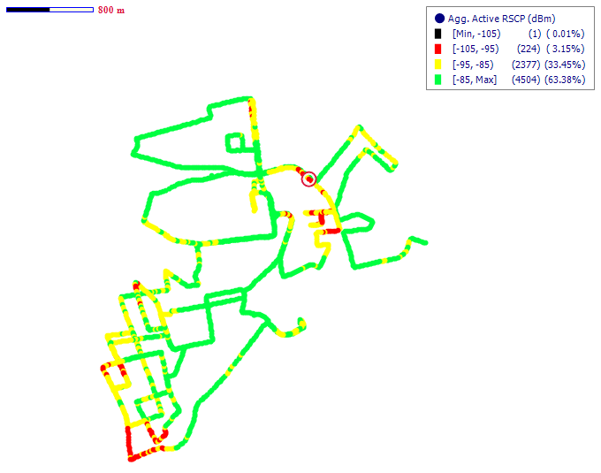
Fig. 10 - Glo 3G Coverage Map, Accra - February 2016
Remarks: Fair 3G coverage in Accra however improvement is needed

COVERAGE AT ADA FOAH

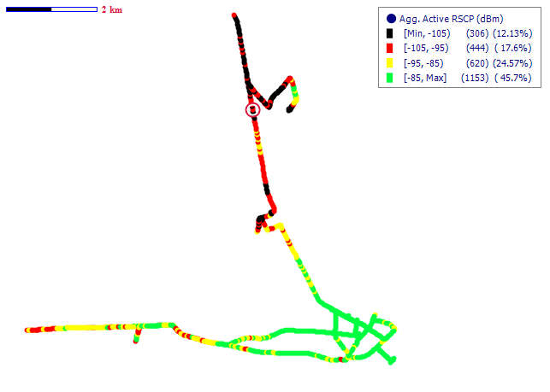
Fig. 11 – MTN 3G Coverage Map, Ada Foah - February 2016
Remarks: Good 3G network coverage in Ada Foah.

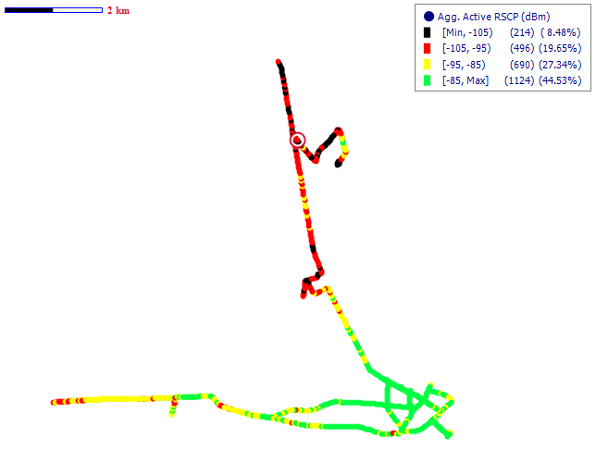
Fig. 12- Vodafone 3G Coverage Map, Ada Foah –February 2016
Remarks: Fair 3G network coverage in Ada Foah however improvement is needed
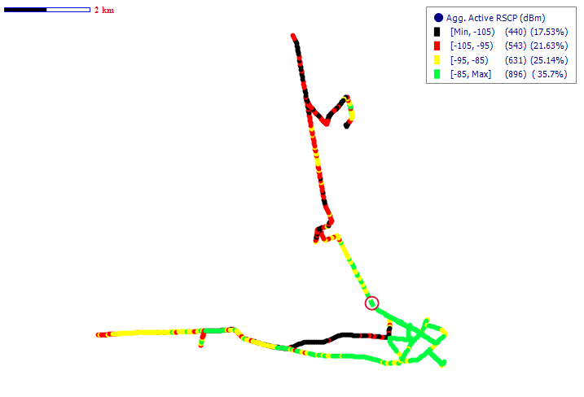

Fig. 13- Airtel 3G Coverage Map, Ada Foah - February 2016
Remarks: Good 3G network coverage in Ada Foah

COVERAGE AT ADENTA
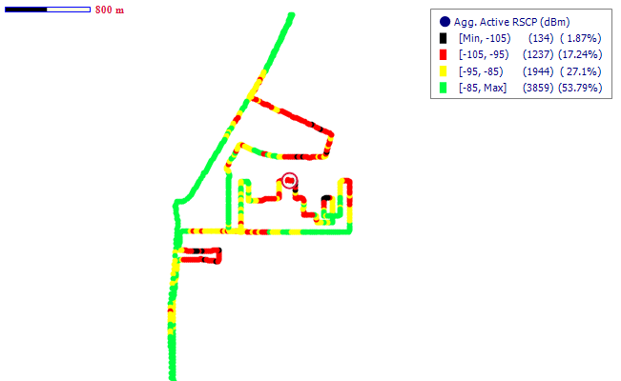
Fig. 14 - MTN 3G Coverage Map, Adenta- February 2016
Remarks: Good 3G network coverage in Adenta.
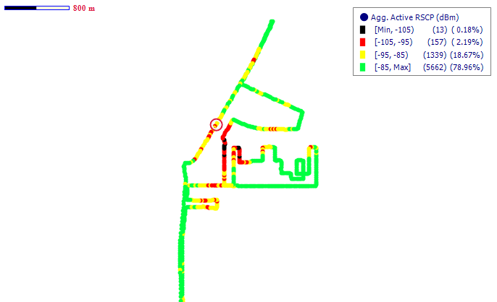
Fig. 15 - Vodafone 3G Coverage Map, Adenta - February 2016
Remarks: Good 3G network coverage in Adenta.

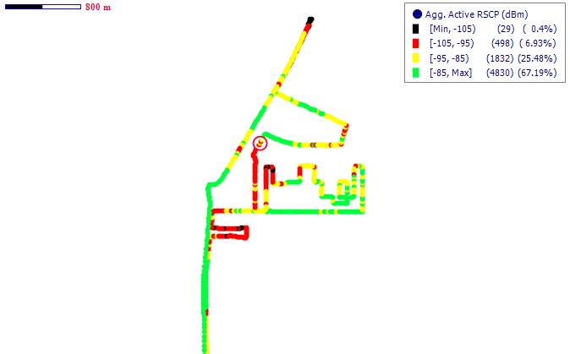
Fig. 16 - Tigo 3G Coverage Map, Adenta - February 2016

Remarks: Good 3G coverage in Adenta

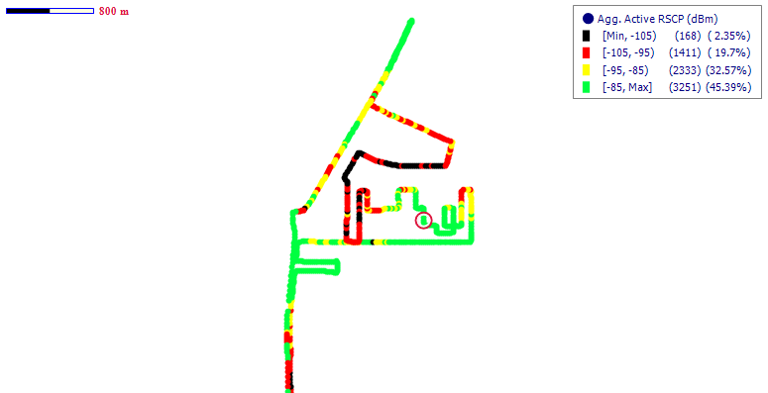

Fig. 17 – Airtel 3G Coverage Map, Adenta - February 2016

Remarks: Good 3G coverage in Adenta

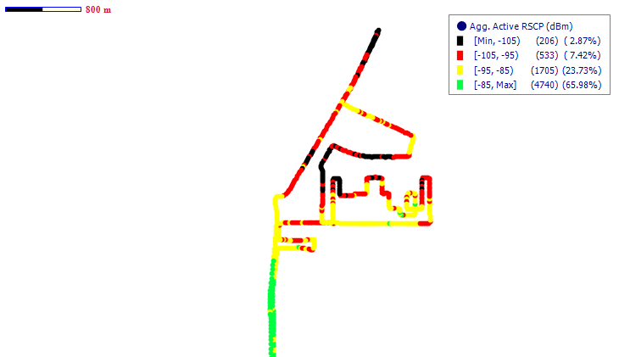
Fig. 18 - Glo 3G Coverage Map, Adenta - February 2016

Remarks: Poor 3G coverage in Adenta that requires improvemen

COVERAGE AT ASHAIMAN

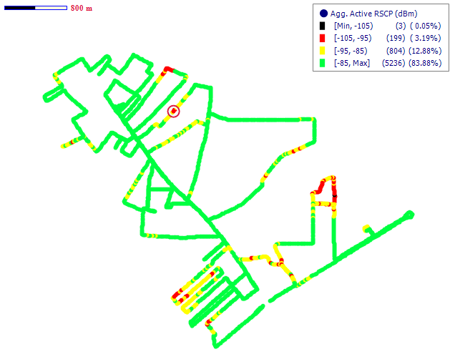
Fig. 19 - MTN 3G Coverage Map, Ashaiman - February 2016

Remarks: Good 3G coverage in Ashaiman

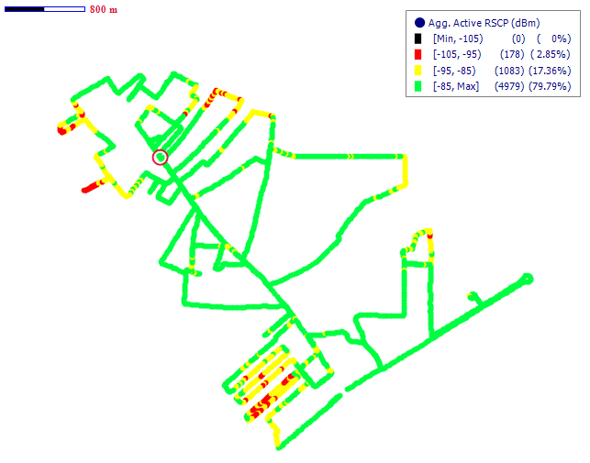

Fig. 20 - Vodafone 3G Coverage Map, Ashaiman - February 2016
Remarks: Good 3G network coverage in Ashaiman

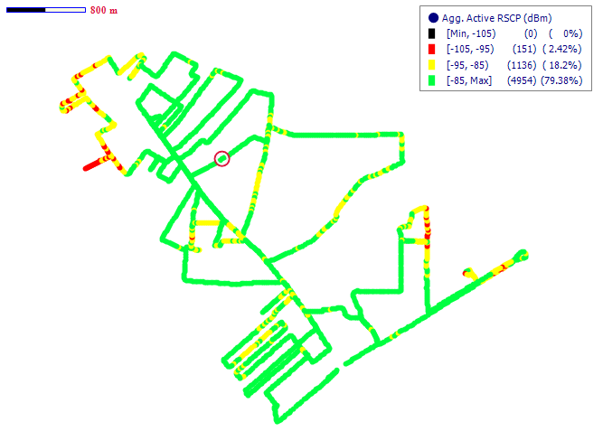
Fig. 21 - Tigo 3G Coverage Map, Ashaiman - February 2016
Remarks: Good 3G network coverage in Ashaiman
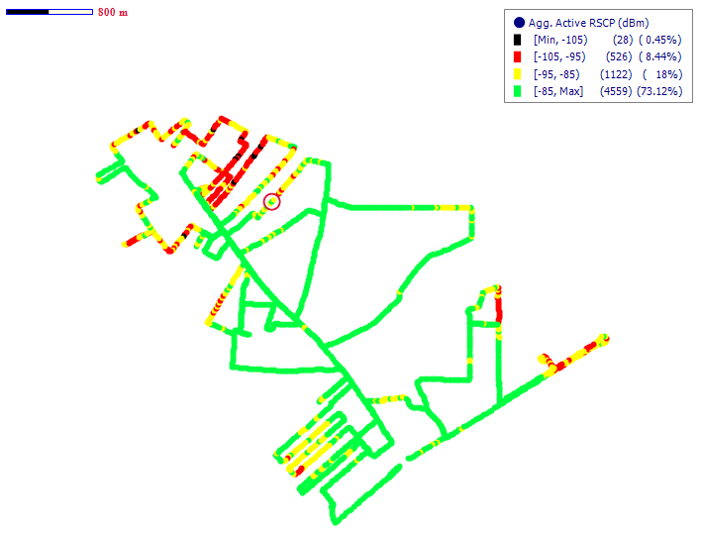
Fig. 22 - Airtel 3G Coverage Map, Ashaiman - February 2016
Remarks: Good 3G network coverage in Ashaiman

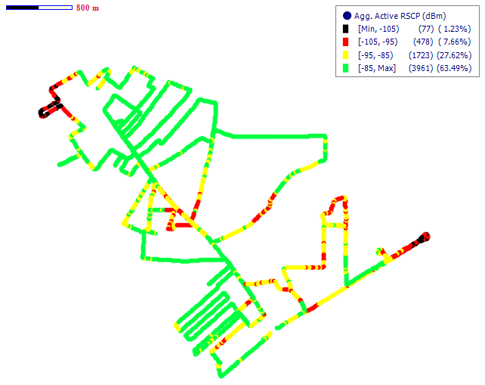
Fig. 23 – Glo 3G Coverage Map, Ashaiman - February 2016
Remarks: Good 3G network coverage in Ashaiman

COVERAGE AT DODOWA
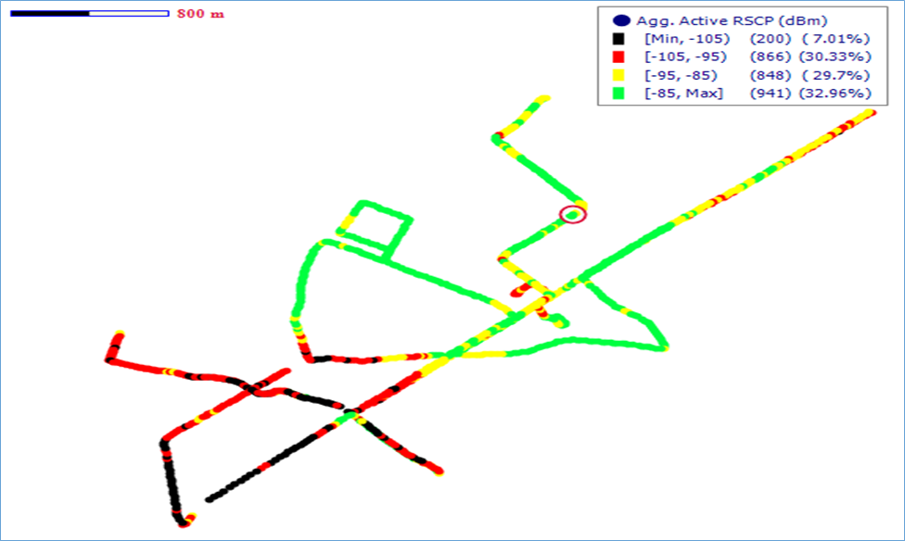
Fig. 24 - MTN 3G Coverage Map, Dodowa - March 2016
Remarks: Good 3G network coverage in Dodowa.

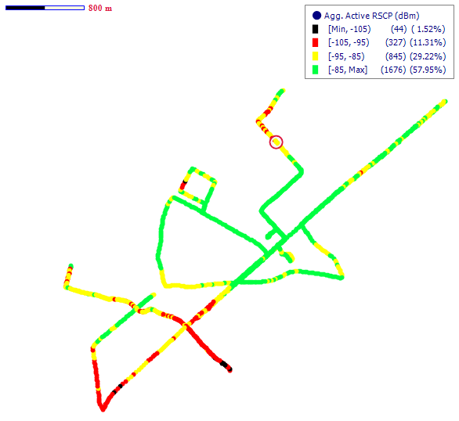

Fig. 25 - Vodafone 3G Coverage Map, Dodowa - February 2016
Remarks: Good 3G network coverage in Dodowa.

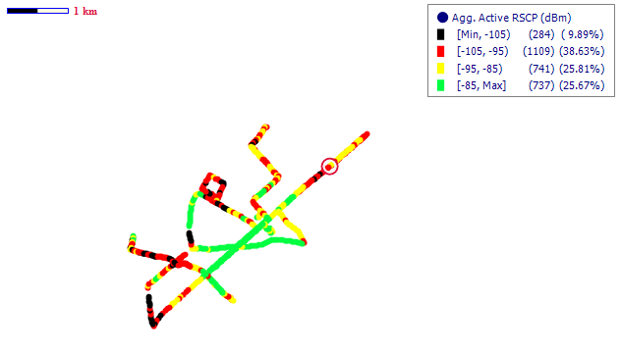
Fig. 26 - Tigo 3G Coverage Map, Dodowa – February 2016
Remarks: Fair 3G network coverage in Dodowa however improvement is needed

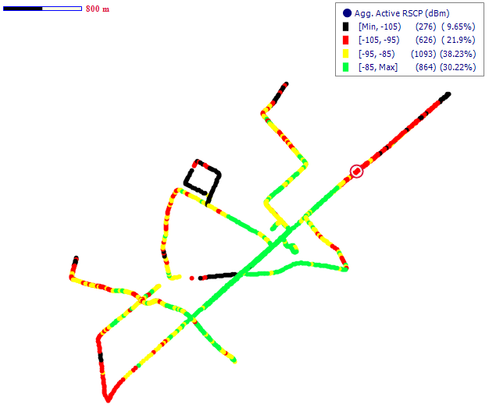
Fig. 27 - Airtel 3G Coverage Map, Dodowa – February 2016
Remarks: Fair 3G network coverage in Dodowa however improvement is needed

COVERAGE AT GBAWE
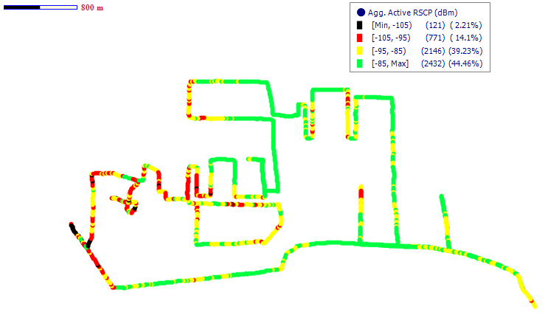
Fig. 28 - MTN 3G Coverage Map, Gbawe - February 2016
Remarks: Good 3G coverage at Gbawe

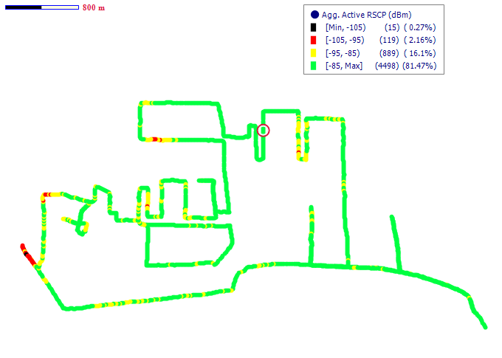
Fig. 29 - Vodafone 3G Coverage Map, Gbawe- February 2016
Remarks: Good 3G network coverage in Gbawe

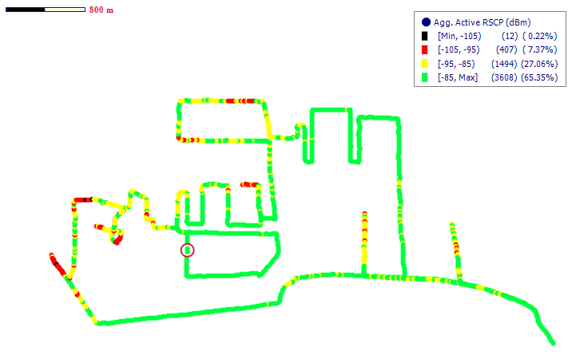
Fig. 30 – Tigo 3G Coverage Map, Gbawe- February 2016
Remarks: Good 3G network coverage in Gbawe
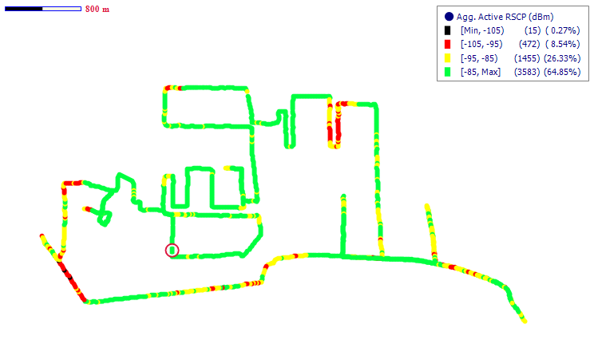
Fig. 31 - Airtel 3G Coverage Map, Gbawe- February 2016
Remarks: Good 3G network coverage in Gbawe

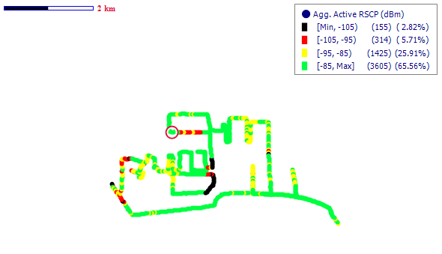

Fig. 32 – Glo 3G Coverage Map, Gbawe- February 2016
Remarks: Good 3G network coverage in Gbawe
COVERAGE AT KPONE
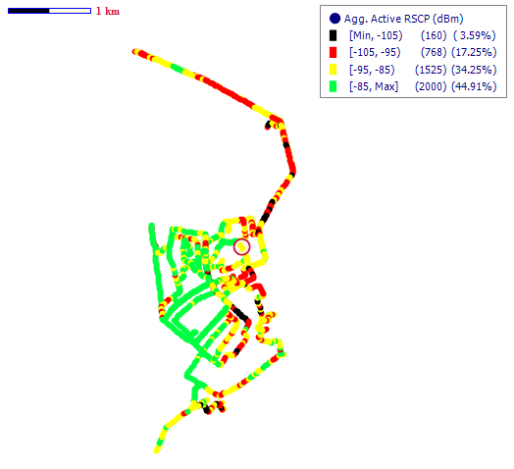
Fig. 33 - MTN 3G Coverage Map, Kpone - February 2016
Remarks: Good 3G coverage at Kpone.

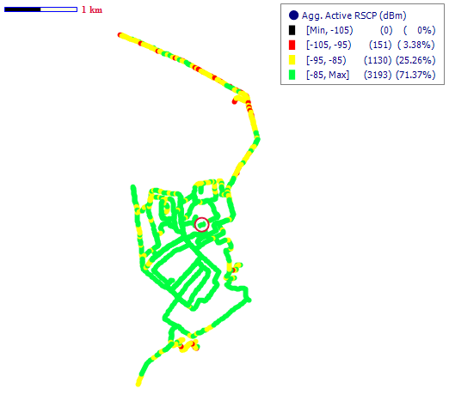
Fig. 34 - Vodafone 3G Coverage Map, Kpone - February 2016
Remarks: Good 3G coverage at Kpone

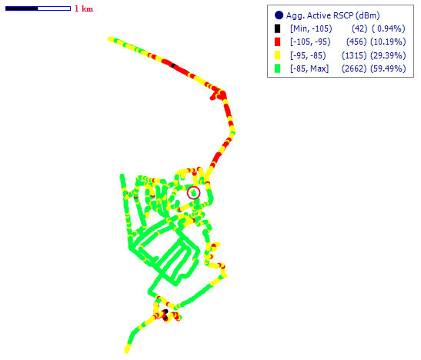
Fig. 35 - Tigo 3G Coverage Map, Kpone - February 2016
Remarks: Good 3G coverage at Kpone

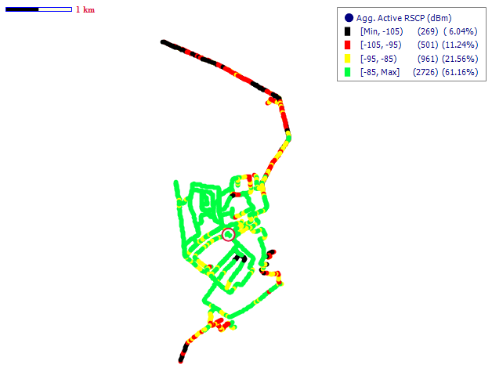
Fig. 36 – Airtel 3G Coverage Map, Kpone - February 2016

Remarks: Good 3G coverage at Kpone.
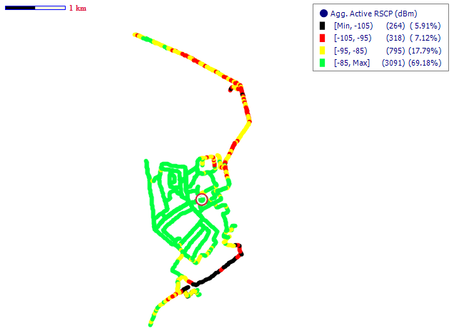
Fig. 37 – Glo 3G Coverage Map, Kpone - February 2016

Remarks: Good 3G coverage at Kpone.

COVERAGE AT LA

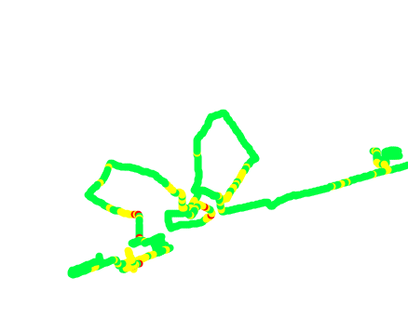
Fig. 38 - MTN 3G Coverage Map, La– January 2016
Remarks: Good 3G coverage in La.

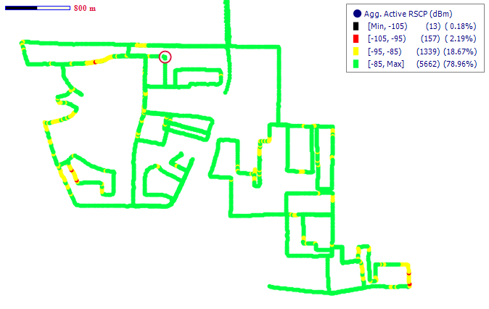
Fig. 39 - Vodafone 3G Coverage Map, La - January 2016
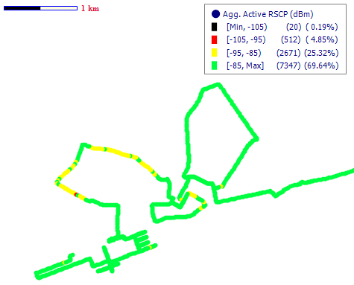
Remarks: Good 3G network coverage in La

Fig. 40 - Tigo 3G Coverage Map, La - January 2016
Remarks: Good 3G coverage in La
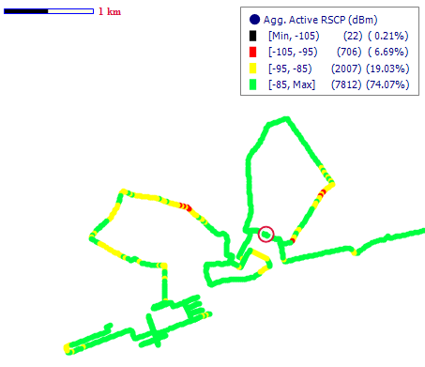
Fig. 41 - Airtel 3G Coverage Map, La - January 2016
Remarks: Good 3G coverage in La

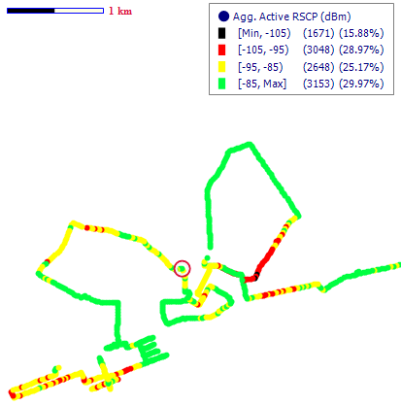
Fig. 42 – Glo 3G Coverage Map, La - January 2016
Remarks: Good 3G coverage in La

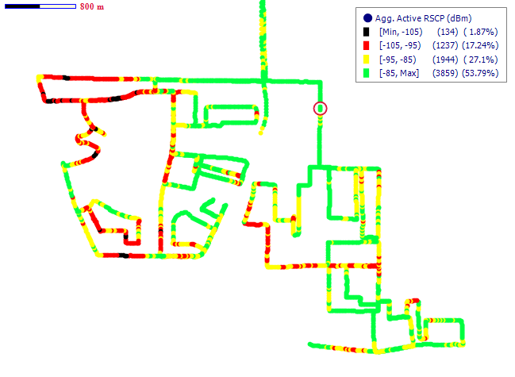
COVERAGE AT MADINA

Fig. 43 - MTN 3G Coverage Map, Madina - February 2016
Remarks: Good 3G network coverage

Fig. 44 - Vodafone 3G Coverage Map, Madina - February2016

Remarks: Good 3G network coverage
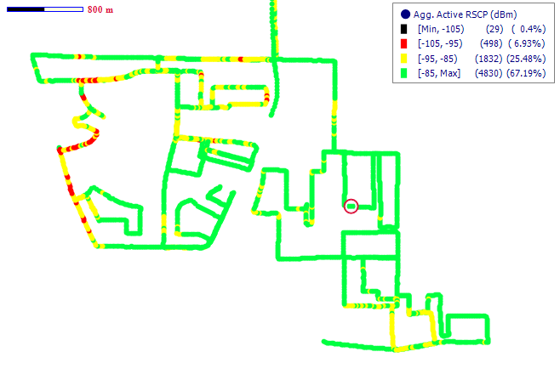
Fig. 45 - Tigo 3G Coverage Map, Madina - February 2016
Remarks: Good 3G network coverage
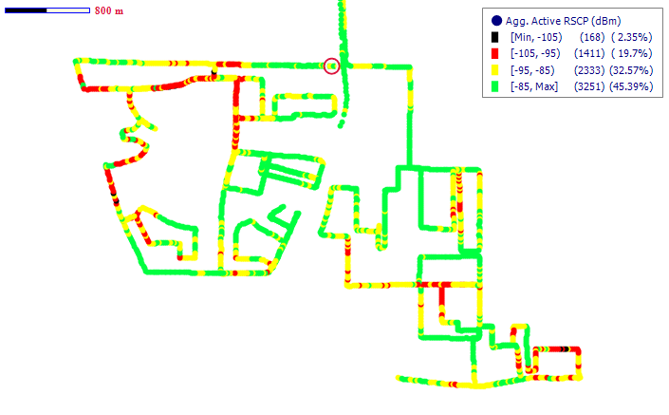

Fig. 46- Airtel 3G Coverage Map, Madina - February 2016
Remarks: Fair 3G network coverage. However, improvement is needed

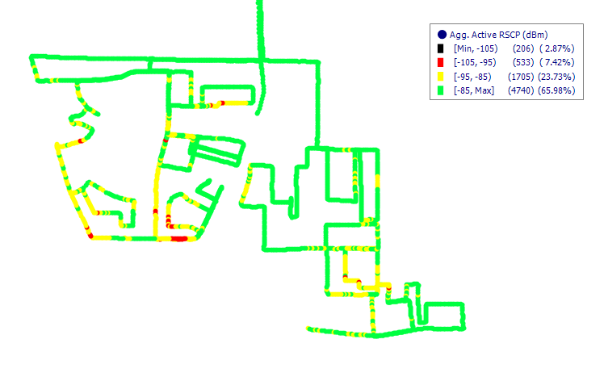
Fig. 47 – Glo 3G Coverage Map, Madina - February 2016
Remarks: Good 3G coverage in and around Madina.

COVERAGE AT PRAMPRAM
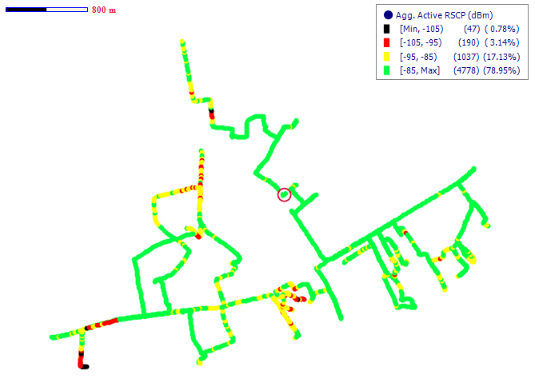
Fig. 48 - MTN 3G Coverage Map, Prampram - February 2016
Remarks: Good 3G network coverage in Prampram

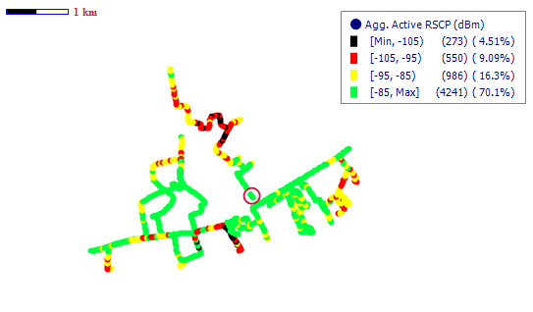
Fig. 49 - Vodafone 3G Coverage Map, Prampram - February 2016
Remarks: Good 3G network coverage in Prampram.
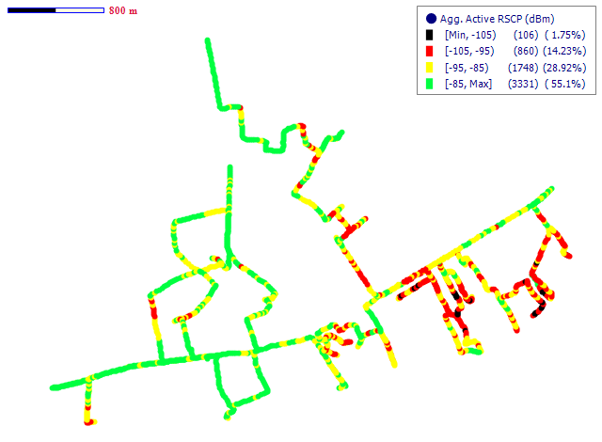
Fig. 50 - Tigo 3G Coverage Map, Prampram - February 2016

Remarks: Good 3G network coverage in Prampram.
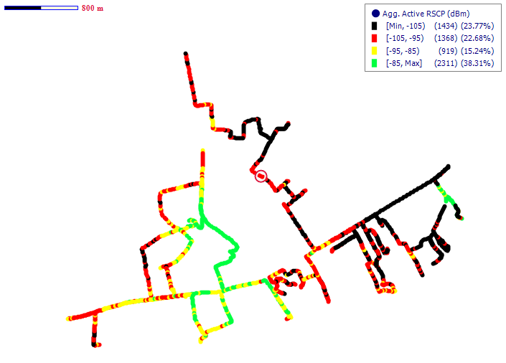

Fig. 51 - Airtel 3G Coverage Map, Prampram - February2016
Remarks: Fair 3G coverage in Prampram. However, improvement is needed

COVERAGE AT SEGE
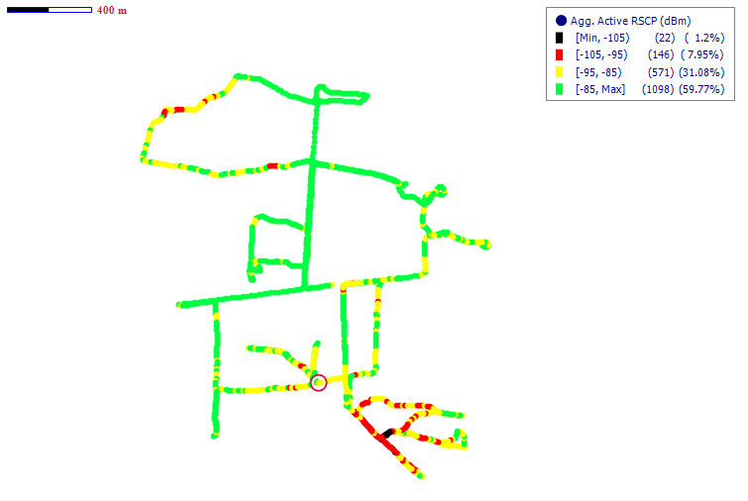
Fig. 52 - MTN 3G Coverage Map, Sege - February 2016
Remarks: Good 3G Coverage in Sege

COVERAGE AT SOWUTUOM
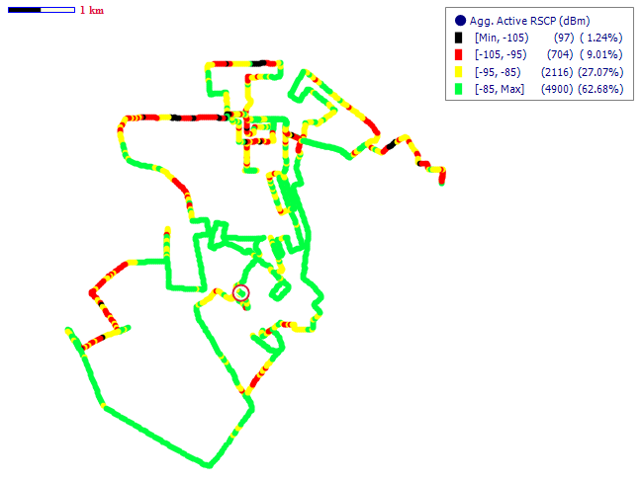
Fig. 53 - MTN 3G Coverage Map, Sowutuom - February 2016
Remarks: Good 3G coverage in Sowutuom
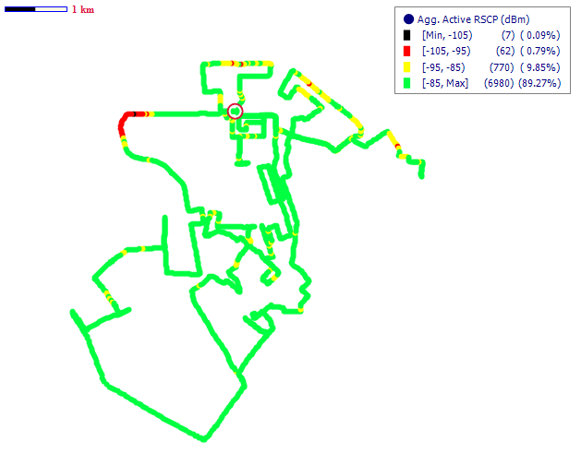
Fig. 54 - Vodafone 3G Coverage Map, Sowutuom - February 2016
Remarks: Good 3G coverage in Sowutuom
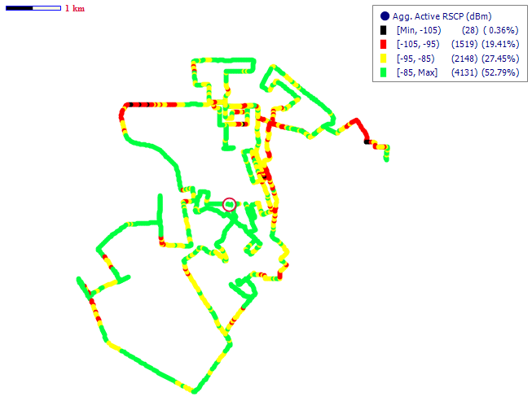
Fig. 55 - Tigo 3G Coverage Map, Sowutuom - February 2016
Remarks: Good 3G coverage in Sowutuom
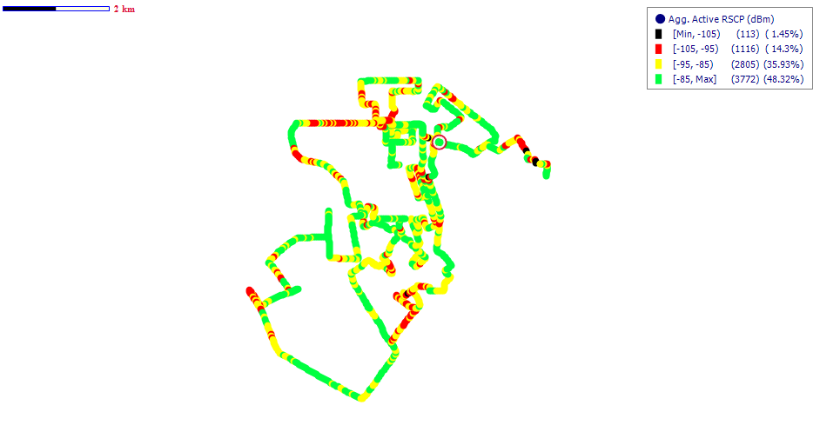
Fig. 56 - Airtel 3G Coverage Map, Sowutuom - February 2016
Remarks: Good 3G coverage in Sowutuom.

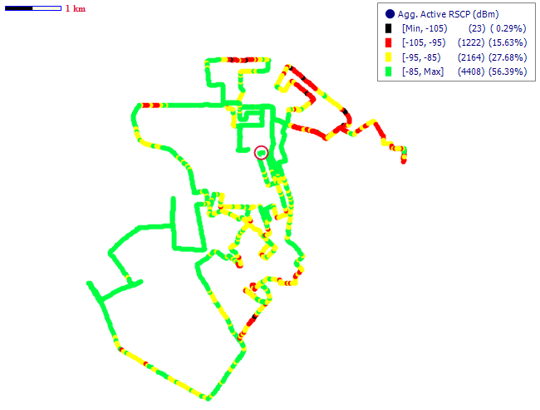
Fig. 57 – Glo 3G Coverage Map, Sowutuom - February 2016
Remarks: Good 3G coverage in Sowutuom.

COVERAGE AT TEMA
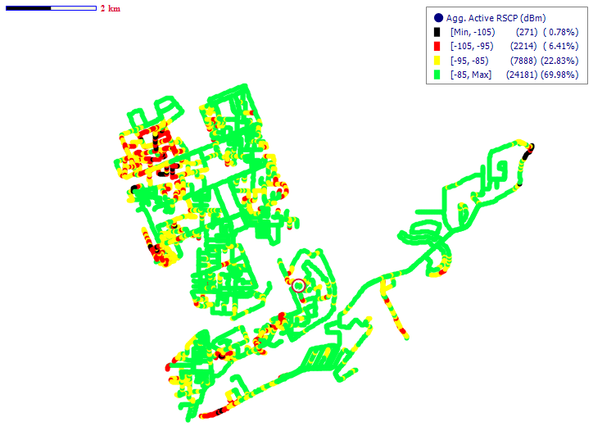
Fig. 58 - MTN 3G Coverage Map, Tema - February2016
Remarks: Good 3G network coverage in Tema

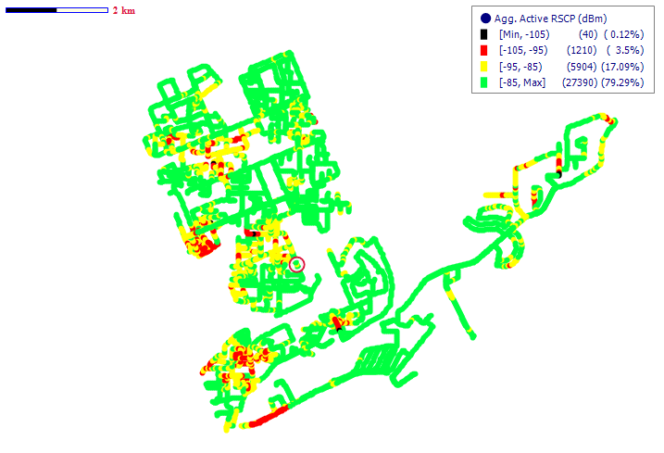
Fig. 59 - Vodafone 3G Coverage Map, Tema - February2016
Remarks: Good 3G coverage in Tema
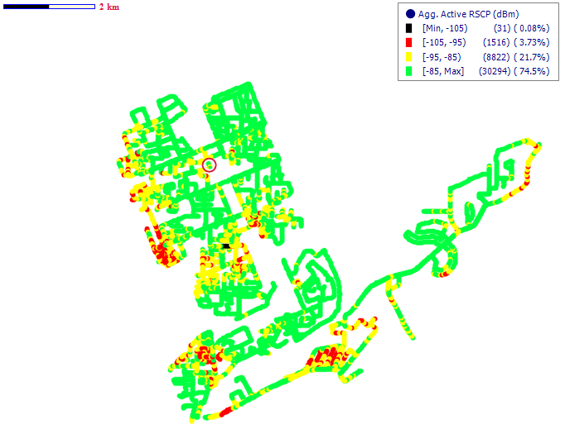
Fig. 60 – Tigo 3G Coverage Map, Tema - February2016
Remarks: Good 3G coverage in Tema.

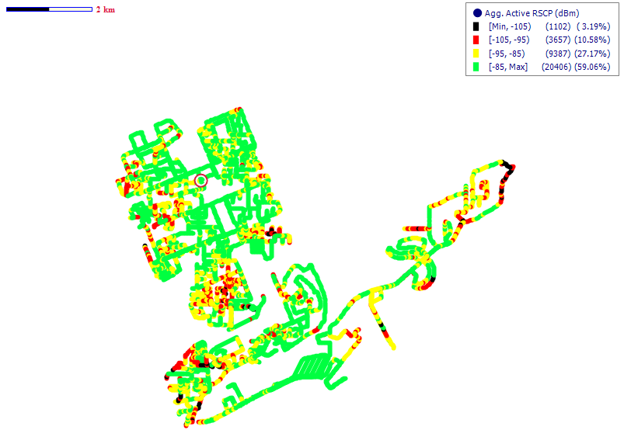
Fig. 61 - Airtel 3G Coverage Map, Tema - February2016
Remarks: Good 3G coverage in Tema.
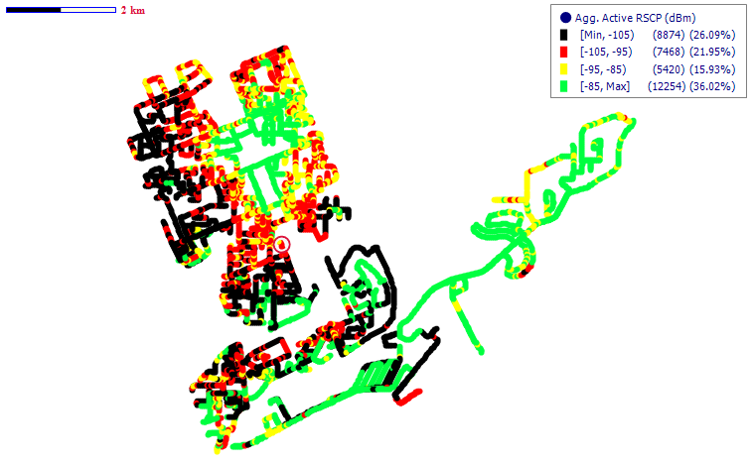
Fig. 62 - Glo 3G Coverage Map, Tema - February2016
Remarks: Poor 3G coverage in Tema which requires a major improvement in and around the Tema Metropolitan area.

COVERAGE AT TESHIE NUNGUA

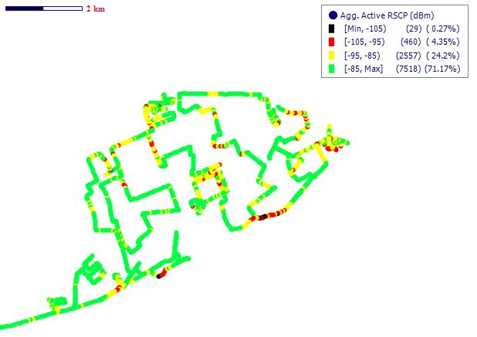
Fig. 63 - MTN 3G Coverage Map, Teshie Nungua – January 2016
Remarks: Good 3G network coverage in Teshie Nungua
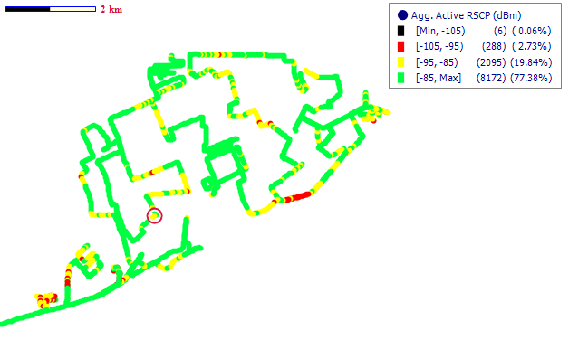
Fig. 64- Vodafone 3G Coverage Map, Teshie Nungua – January 2016
Remarks: Good 3G coverage in Teshie Nungua

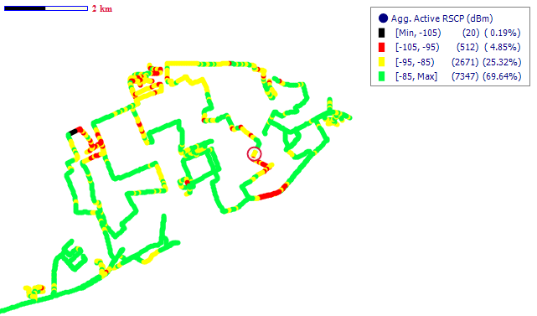
Fig. 65 – Tigo 3G Coverage Map, Teshie Nungua – January 2016
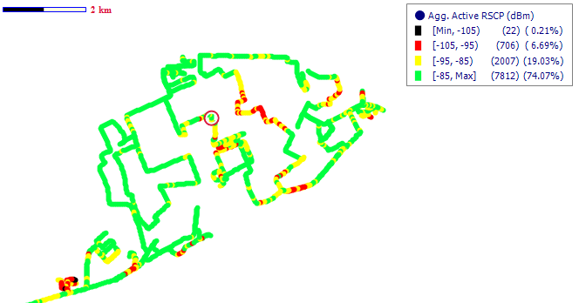
Remarks: Good 3G coverage in Teshie Nungua

Fig. 66 - Airtel 3G Coverage Map, Teshie Nungua – January 2016
Remarks: Good 3G coverage in Teshie Nungua

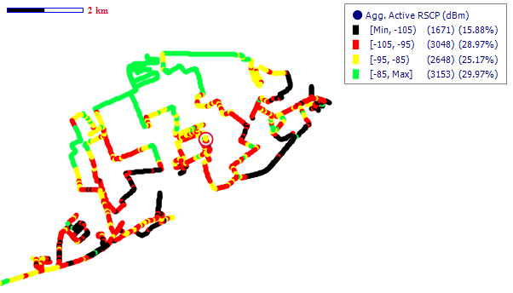
Fig. 67 - Glo 3G Coverage Map, Teshie Nungua – January 2016
Remarks: Poor 3G coverage in Teshie Nungua. A major improvement is required

APPENDIX II
RSCP SAMPLING DISTRIBUTION
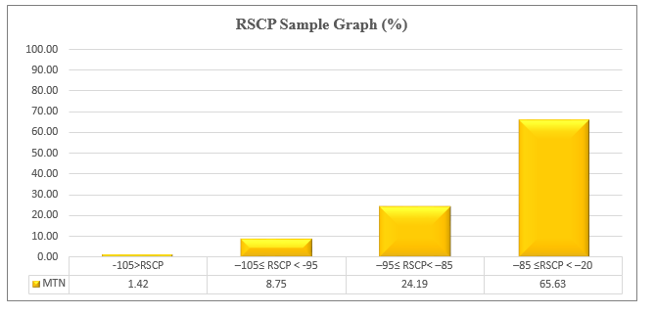
Fig. 68 - MTN 3G Coverage Samples Plot in the Greater Accra Region

Remarks: MTN recorded its highest count of RSCP samples in the range –85 ≤RSCP < –20 dBm; representing “Good” 3G coverage across most of the District Capitals tested in the Greater Accra Region.
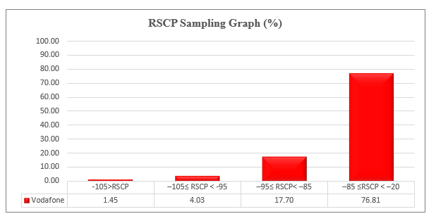Fig. 69 - Vodafone 3G Coverage Samples Plot in the Greater Accra Region
Remarks: Vodafone recorded its highest count of RSCP samples in the range –85 ≤RSCP < –20 dBm; representing “Good” 3G coverage across most of the District Capitals tested in the Greater Accra Region.
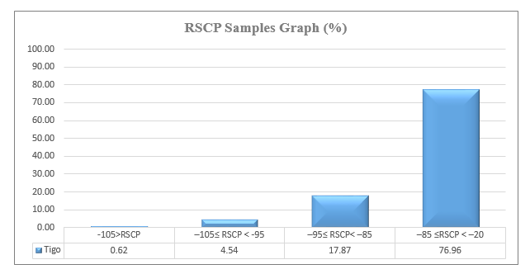
Fig. 70 - Tigo 3G Coverage Samples Plot in the Greater Accra Region

Remarks: Tigo recorded its highest count of RSCP samples in the range –85≤RSCP < –20 dBm; representing “Good” 3G coverage across most of the District Capitals tested in the Greater Accra Region
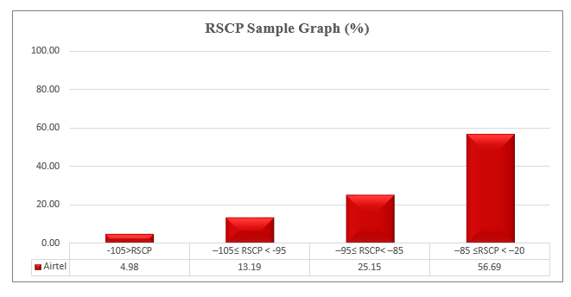Fig. 71 - Airtel 3G Coverage Samples Plot in the Greater Accra Region
Remarks: Airtel recorded its highest count of RSCP samples in the range –85 ≤RSCP < –20 dBm; representing “Good” 3G coverage across most of the District Capitals tested in the Greater Accra Region.

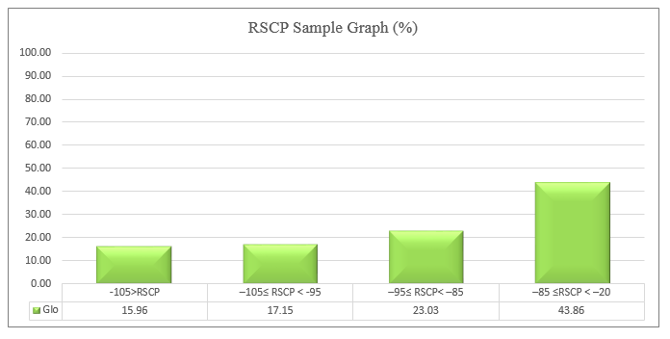
Fig. 72 - Glo 3G Coverage Samples Plot in the Greater Accra Region

Remarks: Glo recorded its highest count of RSCP samples in the range –85 ≤RSCP < –20 dBm; representing “Good” 3G coverage across most of the District Capitals tested in the Greater Accra Region

