Quality of Service (QoS) Monitoring of Cellular Mobile Data Services- ASHANTI REGION
[March 2016]
[Communications for Development]


NATIONAL COMMUNICATIONS AUTHORITY

Table of Contents
1. Background 2
2. What we measure 2
3. Findings 2
4. Remedies 7
5. Appendix 7 - 22

Background
In pursuance of obligations of the 3G Cellular Mobile Licence of Telecommunication Operators, the consumer perspective of the quality of data services are tested to ensure the compliance of Operators to the obligations on service quality to the user.
The report is based on findings on quality of data service in the Ashanti region between 13th March and 3rd April, 2016 for all Operators except for Expresso due to technical challenges.

What we measure

As per the 3G Cellular Mobile licence obligations, the QoS indicators and their respective threshold for compliance under assessment considering the user’s perspective are as below;

- Data Access Success Rate (DASR)
- Data Drop Rate (DDR)
- Data Throughput

Findings

The results for the district capitals within Ashanti Region tested during the period are as below:

- Data Access Success Rate

Data Access Success Rate is the probability of success in connecting to the public server.
Data Access Success Rate should be equal or better than ninety five per cent (95%)
For analysis and calculations,
The results for the district capitals tested during the period are as below:

Table 1. Data Access Success Rate, March 2016
District Capital | MTN | Vodafone | Tigo | Airtel | Glo
Agogo | 100 | 100 | No 3G Coverage | 100 | 100
Agona | 100 | 100 | 100 | 100 | 100
Akumadan | 100 | 100 | 100 | 77.78 | No 3G Coverage
Asiwa | 100 | 100 | No 3G Coverage | 100 | No 3G Coverage
Bekwai | 100 | 100 | No 3G Coverage | 100 | 100
Effiduase | 98.33 | 100 | 100 | 100 | 100
Ejisu | 100 | 100 | 100 | 100 | 98.15
Ejura | 100 | 100 | 100 | 100 | No 3G Coverage
Foase | 100 | 100 | No 3G Coverage | No 3G Coverage | No 3G Coverage
Fomena | 100 | 100 | 100 | 100 | No 3G Coverage
Jacobu | 100 | 100 | 100 | 100 | No 3G Coverage
Juaben | 100 | 100 | 100 | 100 | 100
Juaso | 100 | 94.74 | 100 | 100 | 100
Kodie | 100 | 100 | 84.21 | 100 | 100
Konongo | 100 | 100 | 100 | 100 | 100
Kumasi | 100 | 100 | 100 | 96.59 | 100
Kumawu | 100 | 100 | 100 | 100 | No 3G Coverage
Kuntenase | 100 | 100 | 100 | 100 | 100
Mampong | 100 | 100 | 100 | 95.12 | 100
Mamponteng | 100 | 100 | 100 | 97.44 | 100
Mankranso | 100 | 100 | No 3G Coverage | 100 | No 3G Coverage
Manso Nkwanta | 100 | 100 | No 3G Coverage | 100 | No 3G Coverage
New Edubiase | 100 | 100 | 100 | 100 | No 3G Coverage
District Capital | MTN | Vodafone | Tigo | Airtel | Glo
Nkawie | 100 | 100 | 94.44 | No 3G Coverage | 100
Nsuta | 100 | 100 | 100 | 95.56 | No 3G Coverage
Nyinahin | 100 | 100 | 100 | 100 | No 3G Coverage
Obuasi | 100 | 100 | 100 | 100 | 99.5
Offinso | 100 | 100 | 100 | 100 | 100
Tepa | 100 | 100 | 100 | 100 | No 3G Coverage
REMARKS:
- MTN and Glo complied with the Data Access Success Rate obligation in the available District Capitals tested.
- Vodafone failed to meet the Data Access Success Rate obligation at Juaso.
- Tigo failed to meet the Data Access Success Rate threshold at Kodie and Nkawie
- Airtel failed to comply with the Data Access Success Rate at Akumadan.

- Data Drop Rate

Data Drop Rate is the probability to drop in connection to a public server without end user’s intervention.
Data Drop Rate should be equal or less than one per cent (1%).
Table 2. Data Drop Rate, March 2016
District Capital | MTN | Vodafone | Tigo | Airtel | Glo
Agogo | 0 | 0 | No 3G Coverage | 0 | 0
Agona | 0 | 0 | 0 | 0 | 0
Akumadan | 0 | 0 | 0 | 0 | No 3G Coverage
Asiwa | 0 | 0 | No 3G Coverage | 0 | No 3G Coverage
Bekwai | 0 | 0 | No 3G Coverage | 0 | 0
District Capital | MTN | Vodafone | Tigo | Airtel | Glo
Effiduase | 0 | 0 | 0 | 0 | 0
Ejisu | 0 | 0 | 0 | 0 | 0
Ejura | 0 | 0 | 0 | 0 | No 3G Coverage
Foase | 0 | 0 | No 3G Coverage | No 3G Coverage | No 3G Coverage
Fomena | 0 | 0 | 0 | 0 | No 3G Coverage
Jacobu | 0 | 0 | 0 | 0 | No 3G Coverage
Juaben | 0 | 0 | 0 | 0 | 0
Juaso | 0 | 0 | 0 | 0 | 0
Kodie | 0 | 0 | 0 | 0 | 0
Konongo | 0 | 0 | 0 | 0 | 0
Kumasi | 0 | 0 | 0 | 0 | 0
Kumawu | 0 | 0 | 0 | 0 | No 3G Coverage
Kuntenase | 0 | 0 | 0 | 0 | 0
Mampong | 0 | 0 | 0 | 0 | 0
Mamponteng | 0 | 0 | 0 | 0 | 0
Mankranso | 0 | 0 | No 3G Coverage | 0 | No 3G Coverage
Manso Nkwanta | 0 | 0 | No 3G Coverage | 0 | No 3G Coverage
New Edubiase | 0 | 0 | 0 | 0 | No 3G Coverage
Nkawie | 0 | 0 | 0 | No 3G Coverage | 0
Nsuta | 0 | 0 | 0 | 0 | No 3G Coverage
Nyinahin | 0 | 0 | 0 | 0 | No 3G Coverage
Obuasi | 0 | 0 | 0 | 0 | 0
Offinso | 0 | 0 | 0 | 0 | 0
Tepa | 0 | 0 | 0 | 0 | No 3G Coverage

REMARKS:
- All Operators complied with the licence threshold of less than one percent (1%) in the available District Capitals tested.
- Data Throughput

Data Throughput is the rate of data transfer.
As per the 3G licence obligations, the minimum data transfer rate for 90% of data connections should be 256kbps or better

Table 3. Data Throughput, March 2016
District Capital | MTN | Vodafone | Tigo | Airtel | Glo
Agogo | 3460 | 1110 | No 3G Coverage | 3890 | 2640
Agona | 4580 | 1230 | 620 | 2650 | 2320
Akumadan | 4770 | 1500 | 1830 | 2310 | No 3G Coverage
Asiwa | 7540 | 1450 | No 3G Coverage | 3010 | No 3G Coverage
Bekwai | 4930 | 1130 | No 3G Coverage | 1540 | 1940
Effiduase | 4400 | 1140 | 1130 | 3960 | 2670
Ejisu | 4410 | 870 | 610 | 4440 | 2260
Ejura | 3260 | 970 | 280 | 1260 | No 3G Coverage
Foase | 4930 | 1280 | No 3G Coverage | No 3G Coverage | No 3G Coverage
Fomena | 5650 | 1450 | 710 | 2610 | No 3G Coverage
Jacobu | 7080 | 1300 | 510 | 6520 | No 3G Coverage
Juaben | 5930 | 190 | 700 | 3380 | 2040
Juaso | 5600 | 960 | 580 | 200 | 8100
Kodie | 1400 | 870 | 530 | 170 | 2750
Konongo | 2040 | 310 | 670 | 1700 | 1500
Kumasi | 4230 | 1390 | 1050 | 1960 | 4630
Kumawu | 7180 | 1120 | 350 | 5100 | No 3G Coverage
District Capital | MTN | Vodafone | Tigo | Airtel | Glo
Kuntenase | 4730 | 1250 | 360 | 440 | 5880
Mampong | 1780 | 270 | 340 | 1830 | 2690
Mamponteng | 2680 | 1380 | 660 | 1620 | 2220
Mankranso | 5880 | 1580 | No 3G Coverage | 4090 | No 3G Coverage
Manso Nkwanta | 5150 | 1400 | No 3G Coverage | 7130 | No 3G Coverage
New Edubiase | 3760 | 1250 | 470 | 3360 | No 3G Coverage
Nkawie | 4550 | 1480 | 1390 | No 3G Coverage | 1490
Nsuta | 4750 | 1270 | 490 | 2720 | No 3G Coverage
Nyinahin | 6510 | 1030 | 490 | 4090 | No 3G Coverage
Obuasi | 6160 | 970 | 590 | 2540 | 1980
Offinso | 3220 | 1590 | 890 | 970 | 2790
Tepa | 4060 | 1580 | 870 | 5520 | No 3G Coverage
REMARKS:
- MTN, Tigo and Glo met the Data Throuhgput threshold in the available District Capitals tested.
- Airtel failed to attain the Data Throughput threshold at Juaso and Kodie
- Vodafone failed to attain the Data Throughput at Juaben.

REMEDIES
- The NCA has notified Operators of publication of these findings and directed all Operators to improve any obligation in default by June 2016.
- Sanctions will be applied to Operators on obligations in default after June 2016.
- All Operators were directed to improve their 3G service in some localities by August, 2016 and ensure continuous compliance in all areas at all times.

APPENDIX 1
The Graphs below show the Throughput levels attained by Operators in each location where monitoring was performed.

Figure 1. Data Throughput - March 2016, Agogo

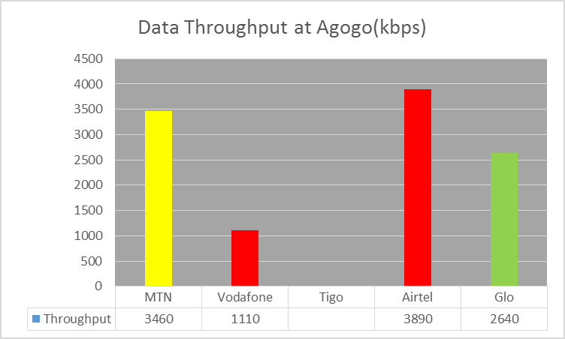
REMARKS:
- All Mobile Network Operators (MNOs) except Tigo exceeded the Throughput threshold of 256kbps.
- Tigo had no 3G Service at the time of the tests.

Figure 2. Data Throughput - March 2016, Agona
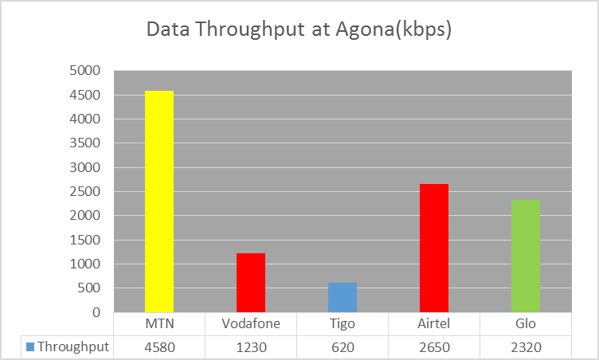
REMARKS:
- All MNOs exceeded the Throughput threshold of 256kbps.

Figure 3. Data Throughput February-March 2016, Akumadan
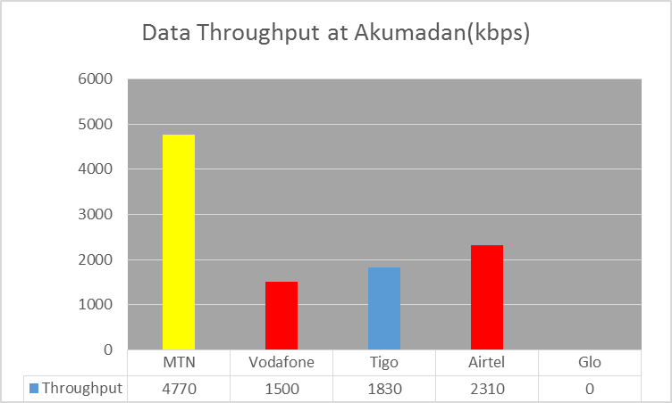
REMARKS:
- All MNOs except Glo exceeded the threshold of 256kbps.
- Glo had no 3G Service at the time of the tests.

Figure 4. Data Throughput - March 2016, Asiwa
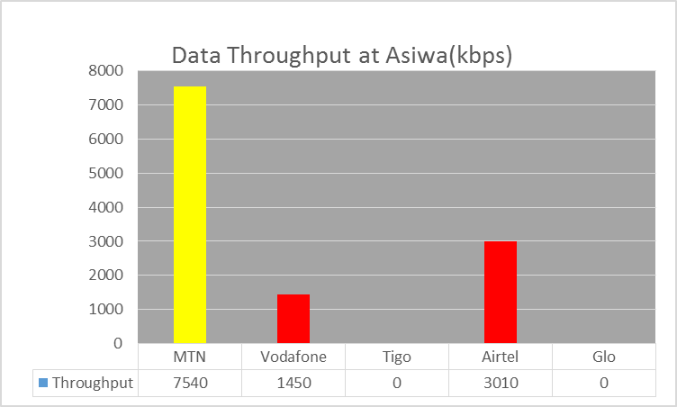
REMARKS:
- MTN, Vodafone and Airtel exceeded Data Throughput threshold.
- Tigo and Glo had no 3G Service at the time of the tests.

Figure 5. Data Throughput - March 2016, Bekwai
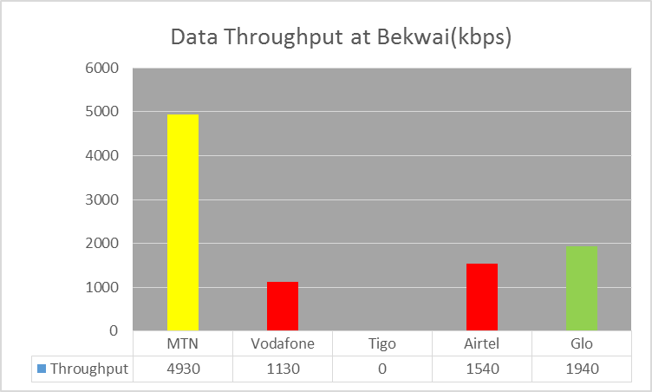
REMARKS:
- All MNOs except Tigo exceeded Data Throughput threshold.
- Tigo had no 3G Service at the time of the tests.

Figure 6. Data Throughput - March 2016, Effiduase

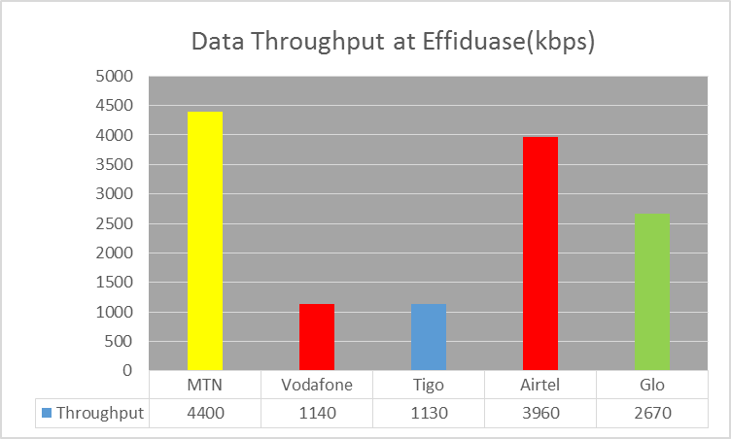
REMARKS:
- All the Operators exceeded the Data Throughput Threshold of 256kbps.

Figure 7. Data Throughput - March 2016, Ejisu
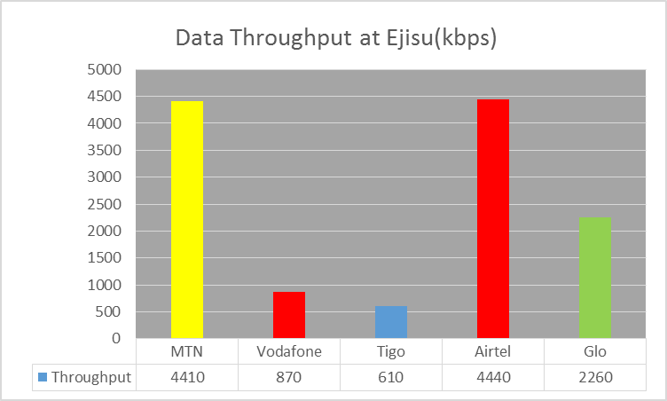
REMARKS:
- All MNOs exceeded the Threshold of 256kbps

Figure 8. Data Throughput - March 2016, Ejura
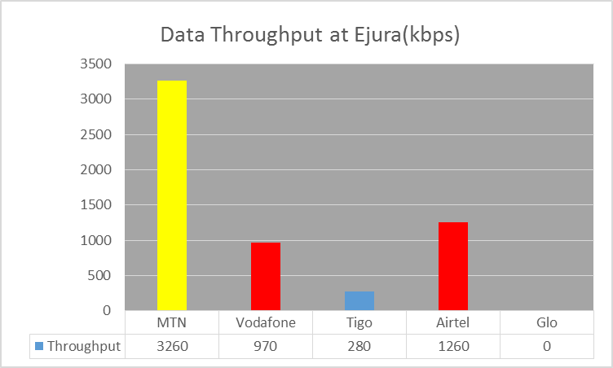
REMARKS:
- All MNOs except Glo exceeded the Threshold of 256kbps.
- Glo had no 3G Service at the time of the tests.
Figure 9. Data Throughput - March 2016, Foase
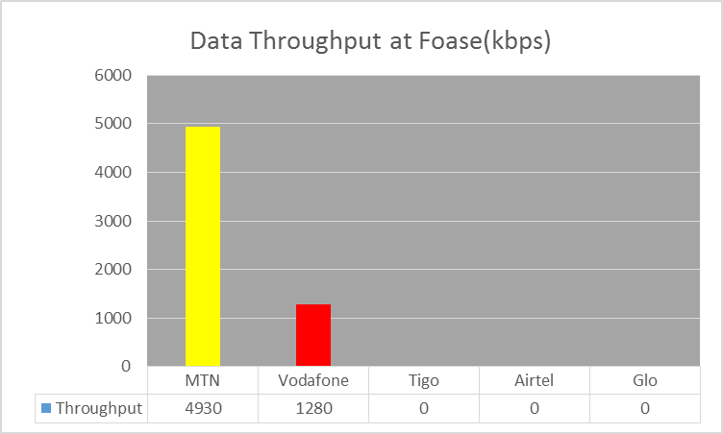
REMARKS:
- MTN and Vodafone exceeded the Threshold of 256kbps.
- Tigo, Airtel and Glo had no 3G Service at the time of the tests.

Figure 10. Data Throughput - March 2016, Fomena
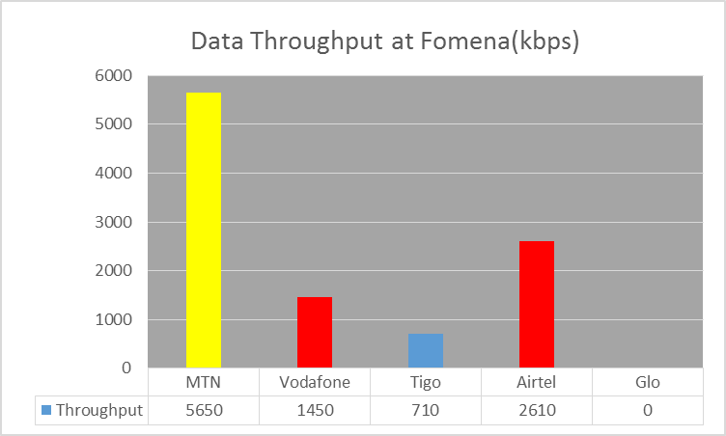
REMARKS:
- All MNOs except Glo exceeded the Threshold of 256kbps
- Glo had no 3G Service at the time of the tests
Figure 11. Data Throughput - March 2016, Jacobu
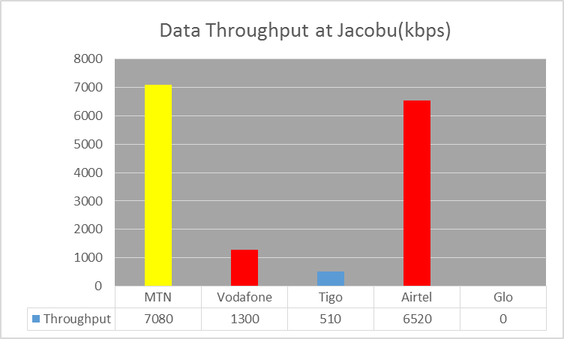
REMARKS:
- All MNOs except Glo exceeded the Threshold of 256kbps.
- Glo had no 3G Service at the time of the tests.

Figure 12. Data Throughput - March 2016, Juaben
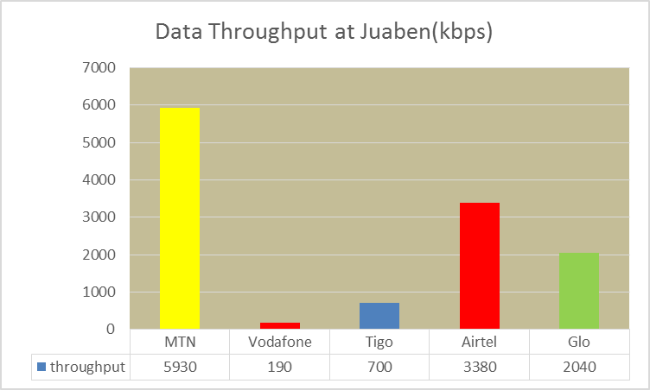
REMARKS:
- All MNOs except Vodafone exceeded the Threshold of 256kbps

Figure 13. Data Throughput - March 2016, Juaso
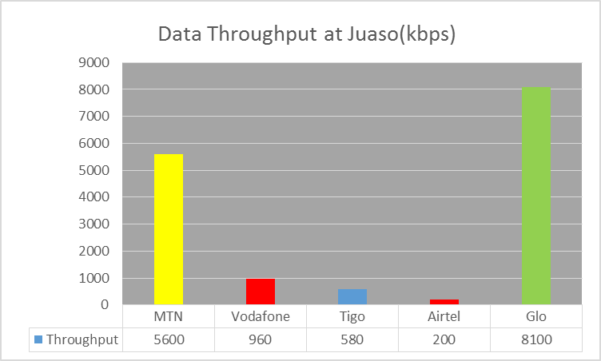
REMARKS:
- All Operators except Airtel exceeded their Throughput threshold.
- Airtel failed to meet the Throughput threshold.

Figure 14. Data Throughput - March 2016, Kodie
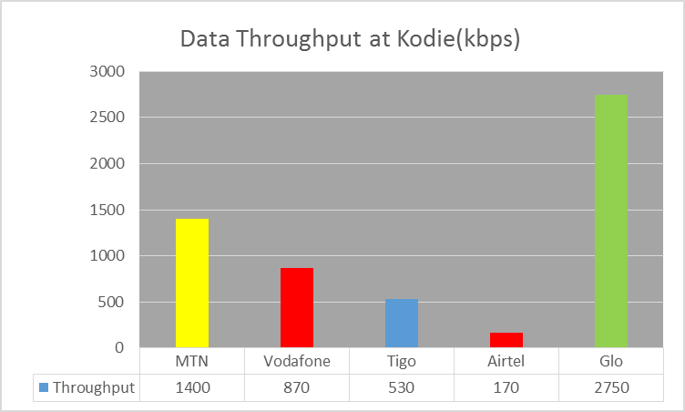
REMARKS:
- All Operators exceeded the Throughput threshold.

Figure 15. Data Throughput - March 2016, Konongo
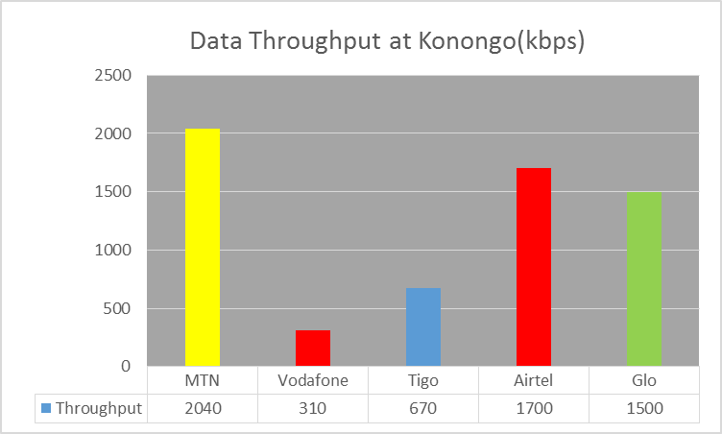
REMARKS:
- All Operators exceeded the Throughput threshold in the tested location.

Figure 16. Data Throughput - March 2016, Kumasi
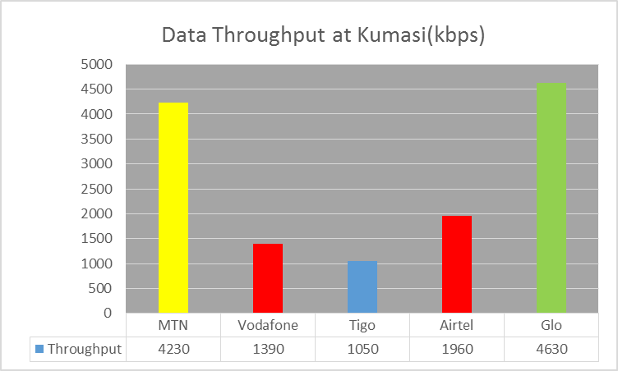
REMARKS:
- All Operators exceeded the Throughput threshold.

Figure 17. Data Throughput - March 2016, Kumawu
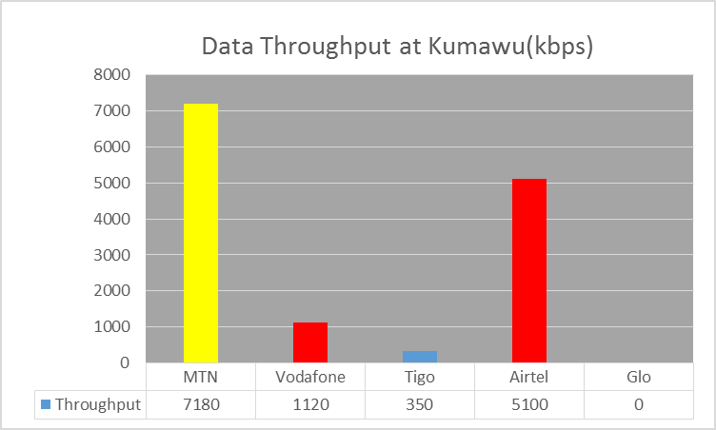
REMARKS:
- All Operators except Glo exceeded the Throughput threshold.
- Glo had no 3G Service at the time of the tests.

Figure 18. Data Throughput - March 2016, Kuntenase
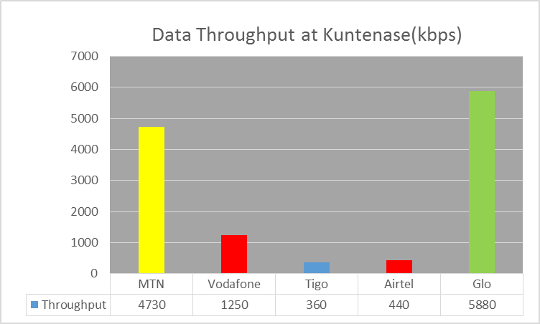
REMARKS:
- All Operators exceeded the Throughput threshold
Figure 19. Data Throughput - March 2016, Mampong

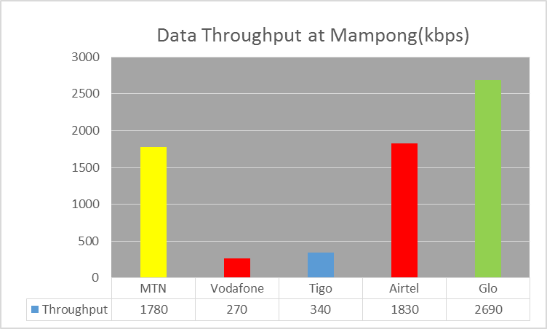
REMARKS:
- All Operators exceeded the Throughput threshold.

Figure 20. Data Throughput - March 2016, Mamponteng
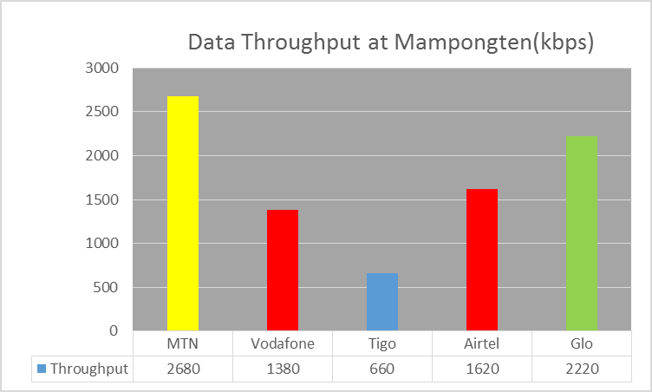
REMARKS:
- All Operators exceeded the Throughput threshold.

Figure 21. Data Throughput - March 2016, Mankranso
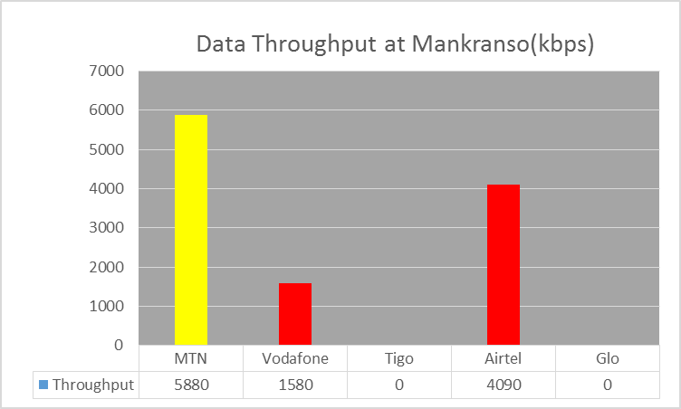
REMARKS:
- MTN, Vodafone and Airtel exceeded the Throughput threshold.
- Tigo and Glo had no 3G Service at the time of the tests..

Figure 22. Data Throughput - March 2016, Manso Nkwanta
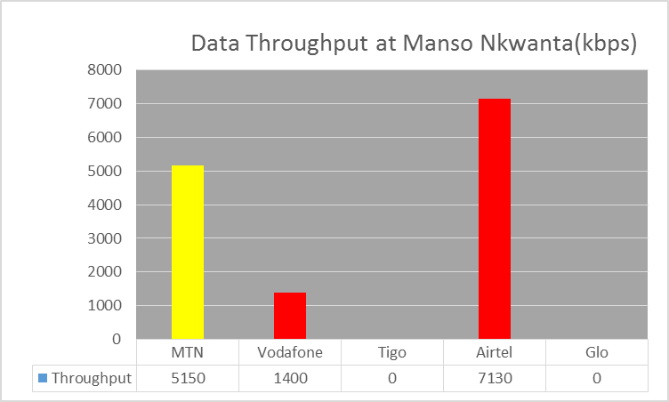
REMARKS:
- MTN, Vodafone and Airtel exceeded the Throughput threshold.
- Tigo and Glo had no 3G Service at the time of the tests.
Figure 23. Data Throughput - March 2016, New Edubiase
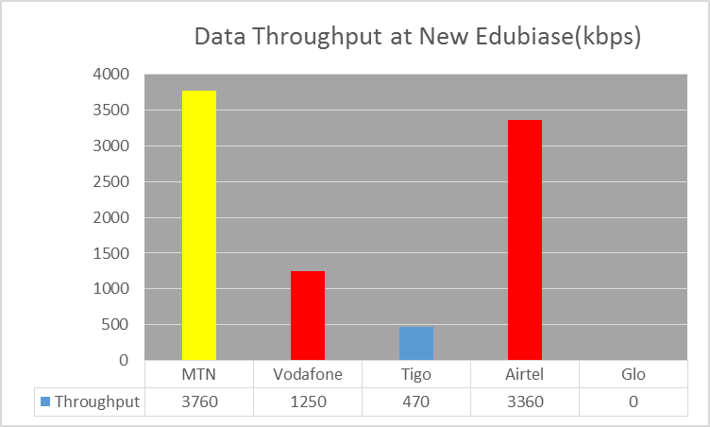
REMARKS:
- All Operators except Glo exceeded the Throughput threshold.
- Glo had no 3G Service at the time of the tests.

Figure 24. Data Throughput - March 2016, Nkawie

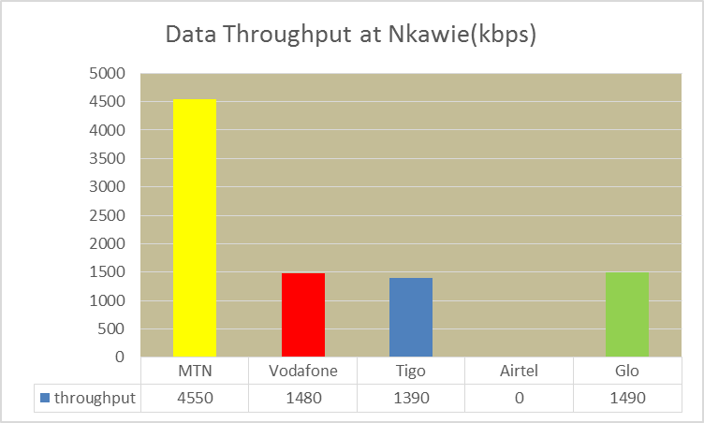
REMARKS:
- All Operators except Airtel exceeded the Throughput threshold.
- Airtel had no 3G Service at the time of the tests.

Figure 25. Data Throughput - March 2016, Nsuta
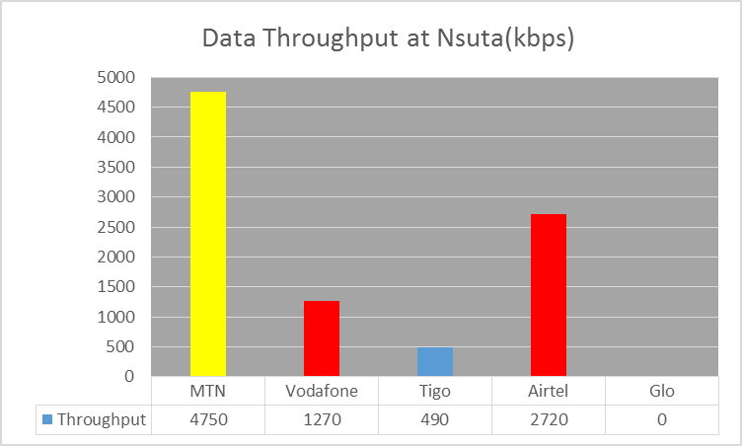
REMARKS:
- All Operators exceeded the Throughput threshold.
- Glo had no 3G Service at the time of the tests.

Figure 26. Data Throughput - March 2016, Nyinahin
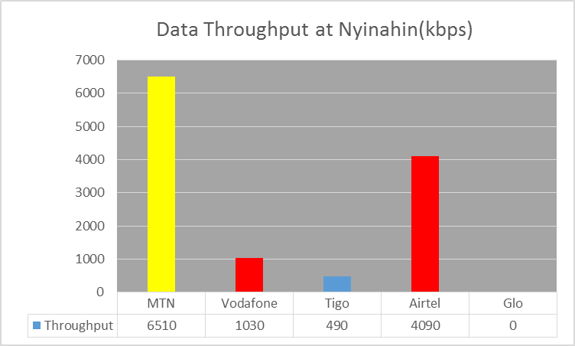
REMARKS:
- All Operators except Glo exceeded the Throughput threshold.
- Glo had no 3G Service at the time of the tests
Figure 27. Data Throughput - March 2016, Obuasi
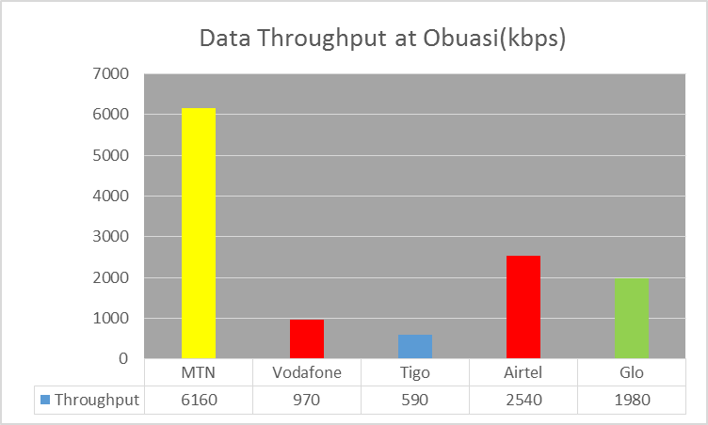
REMARKS:
- All Operators exceeded the Throughput threshold.

Figure 28. Data Throughput - March 2016, Offinso
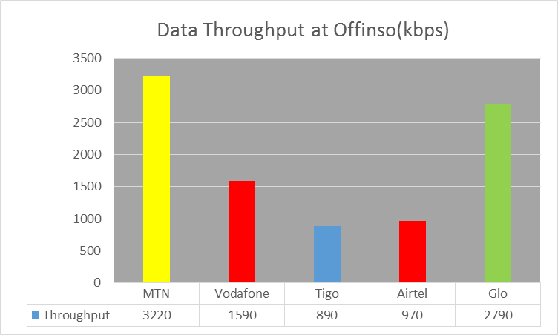
REMARKS:
- All Operators exceeded the Throughput threshold.

Figure 29. Data Throughput - March 2016, Tepa
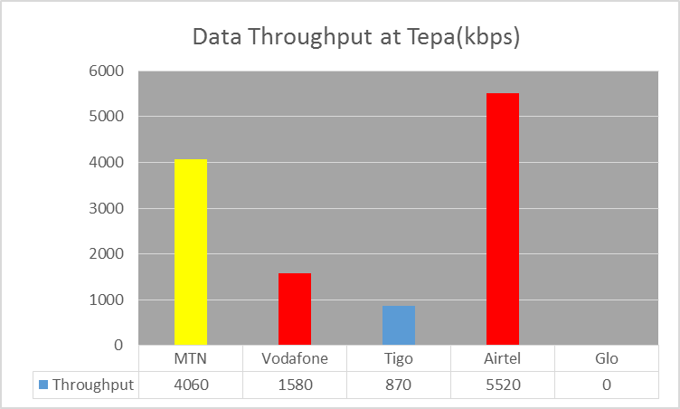
REMARKS:
- All Operators except Glo exceeded the throughput threshold.
- Glo had no 3G Service at the time of the tests.

