NCA HOLDS JOINT PRESS CONFERENCE WITH THE NMC ON THE 2016 GENERAL ELECTIONS
The National Communications Authority (NCA) in collaboration with the National Media Commission (NMC) on the 24th of November 2016 has held a joint press conference on media responsibility in the run up to the 2016 General Elections and the immediate post-election period at the NCA Tower in Accra. The significance of the joint statement was to remind stakeholders of their responsibilities with regards to dissemination of information during the election period.
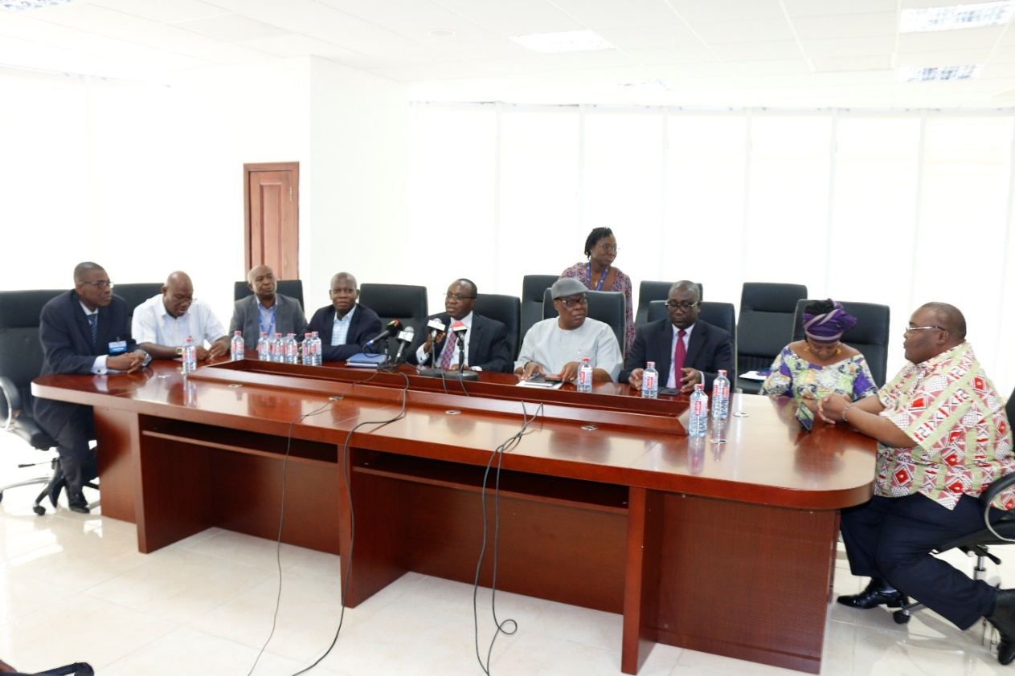
Image 1- Representatives from the NMC and NCA at the Press Conference

Welcoming the media, Mr. Eugene Baffoe-Bonnie, the Board Chairman of the NCA said the two institutions have on previous occasions had similar collaborations which augured well for the country.
On his part and addressing the media at the press conference, Mr. Gyan-Appenteng reminded frequency holders of the obligations they have with regards to their use of their allocated frequencies as stipulated in the various guidelines of the NMC, Code of Conduct of the Ghana Independent Broadcasters’ Association (GIBA) and the Code of Ethics of the Ghana Journalists Association (GJA).
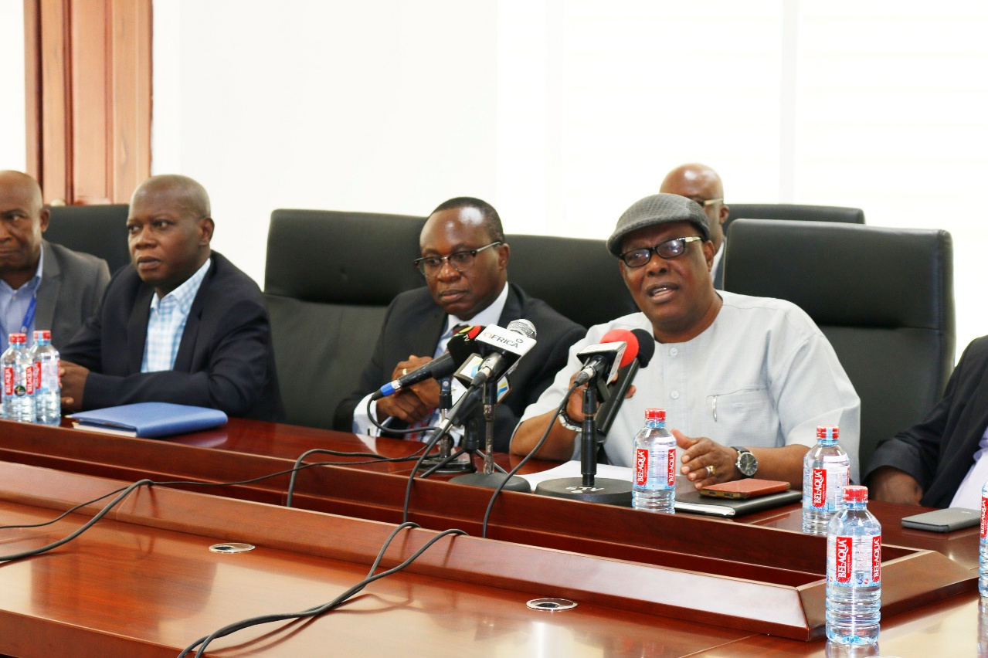
Image 2 - Mr. Gyan-Appenteng, Chairman of the NMC addressing the media

He added that as an important stakeholder of the Authority, the role of the media was crucial in upholding our peace and safeguarding the safety of the nation and citizens by not using their platforms for activities that would threaten our collective peace and security. The broadcasting houses and Mobile Network Operators (MNOs) were also advised to investigate all allegations and claims by interest groups before putting them out and desist from disseminating false news.

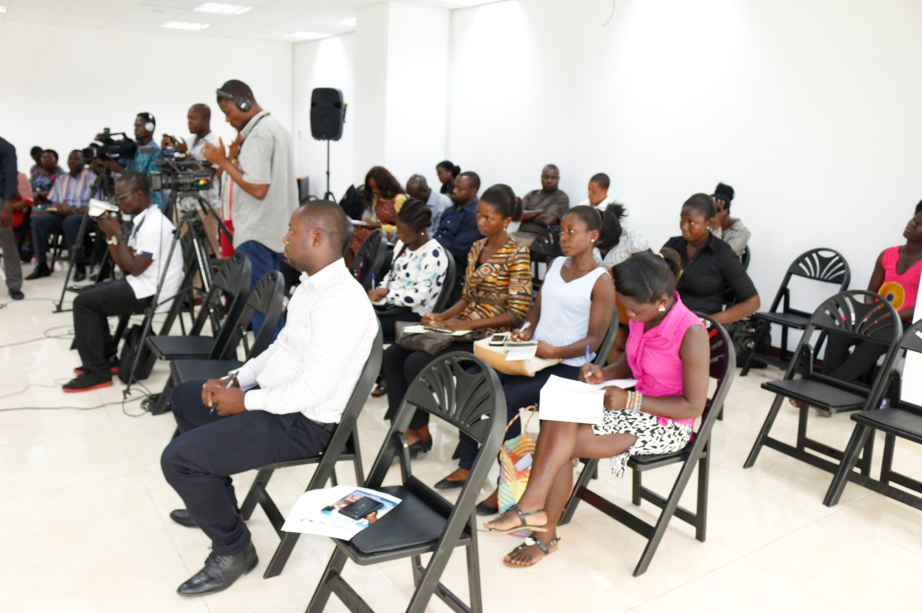
Image 3- A section of the media at the Press Conference

Answering a question on interference, the Director General of the NCA, Mr. William Tevie said that the Authority would be ready to assist media houses which have interference issues during the period. He urged them not to complain on air but to directly engage the relevant authority for quick resolution. On the issue of a shutdown of social media platforms, the DG said, while social media is useful in sharing information, the public should exhibit responsible behaviours in their posts.
Mr. George Sarpong, Executive Secretary of the NMC said that as part of the plans to ensure media responsibility, there would be formal engagements with journalists and hosts of programmes on the choice of language and content. He went on to say that were some mobile and permanent monitoring stations across Ghana as part of the early warning system.
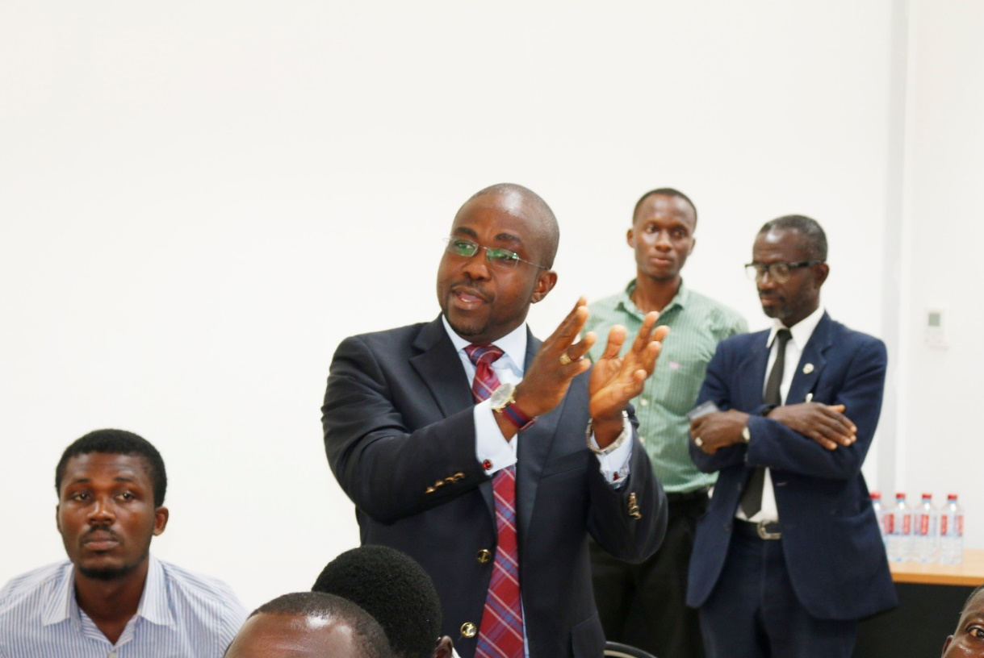
Image 4 - A participant asking a question at the press conference

The NCA and the NMC also assured the general public of their efforts to encourage professionalism in the media and lawful measures including sanctions in place against any media house for non-compliance. The general public were also advised and to redirect any concerns to the NCA or the NMC.

Issued by the National Communications Authority,
NCA Tower,
No. 6 Airport City, Accra.
Tel: (0)30 – 2776621/2771701 or 050-145-1522/3.
E-mail: info@nca.org.gh
Date – Thursday 24th November, 2016

Editor’s Note

About NCA
The National Communications Authority, (NCA), was established by an Act of Parliament, Act 524 in December 1996, which has been repealed and replaced by the National Communications Authority Act, 2008 (Act 769). The Authority is the statutory body mandated to license and to regulate electronic communication activities and services in the country.

